
SANJEEV AGRAWAL GLOBAL EDUCATIONAL UNIVERSITY, BHOPAL

“AI REEL SCROLLER”

A

Major Project Report Submitted to the
SAGE University, Bhopal, M.P.

in partial fulfillment of the requirements for the award of the Degree of B.Tech Specialization in
Computer Science and Engineering VIII Semester
By

Deepak Rathour (20BTE3CSE10050)
Deepesh Dehariya (20BTE3CSE10051)

Chirag Gupta (20BTE3CSE10048)

Under the Guidance of
Mr.Jitendra Sisodiya
(Asst. Professor, SSOET)

SCHOOL OF ENGINEERING AND TECHNOLOGY


SANJEEV AGRAWAL GLOBAL EDUCATIONAL UNIVERSITY, BHOPAL

SCHOOL OF ENGINEERING AND TECHNOLOGY

CERTIFICATE FROM THE SUPERVISOR

This is to certify that the work incorporated in the project report entitled "AI REEL SCROLLER " is a record of work carried out by Deepak Rathour [22BTE3CSE10050] Deepesh Dehariya [22BTE3CSE10051] Chirag Gupta [22BTE3CSE10048] Under my guidance and supervision for the award Degree of MASTER OF TECHNOLOGY SAGE University, Bhopal.
To the best of my/our knowledge and belief the project report
- Embodies the work of the candidate/s himself/themselves,
- II. Has duly been completed,
- III. Fulfills the requirement of the ordinance/guidelines relating to the University and
- IV. Is up to the desired standard both in respect of contents and language for being referred to the examiners.

Supervisor HOD
Mr. Jitendra Sisodiya Dr. Mukesh Dixit
Asst. Professor Head of the Department (SSOET)

The project work as mentioned above is hereby being recommended and Forwarded for examination and evaluation.


SANJEEV AGRAWAL GLOBAL EDUCATIONAL UNIVERSITY, BHOPAL

SCHOOL OF ENGINEERING AND TECHNOLOGY

CANDIDATE’S DECLARATION

I hereby declare that the work, which is being presented in the dissertation phase I, entitled “AI REEL SCROLLER” in partial fulfillment of the requirements for the award of the degree of Bachelor of Technology in “Computer Science and Engineering” submitted in the School of Engineering and Technology, is an authentic record of my own work carried under the Guidance of Mr Jitendra Sisodiya. I have not submitted the matter embodied in this report for award of any other degree.

Supervisor Submitted By
Mr Jitendra Sisodiya
Deepak Rathour 22BTE3CSE10050

Deepesh Dehariya 22BTE3CSE10051

Chirag Gupta 22BTE3CSE10048
Asst. Professor
SSOET


SANJEEV AGRAWAL GLOBAL EDUCATIONAL UNIVERSITY, BHOPAL

SCHOOL OF ENGINEERING AND TECHNOLOGY

CERTIFICATE

This is to certify that the work embodies in this project entitled “ AI REEL SCROLLER” being submitted by Deepak Rathour [22BTE3CSE10050] Deepesh Dehariya [22BTE3CSE10051] Chirag Gupta [22BTE3CSE10048] in partial fulfillment of the requirement for the award of the degree of BTech CSE to School of Engineering and Technology, Sanjeev Agrawal Global Educational University, Bhopal (M.P) during the academic year 2025-26 is a record of bonafide piece of work, undertaken by them under the supervision of the undersigned.

Guided & Approved By
Mr Jitendra Sisodiya
Asst. Professor
School of Engineering & Technology


SANJEEV AGRAWAL GLOBAL EDUCATIONAL UNIVERSITY, BHOPAL

SCHOOL OF ENGINEERING AND TECHNOLOGY

ACKNOWLEDGEMENT

I take the opportunity to express my cordial gratitude to Mr Jitendra Sisodiya , for the valuable guidance and inspiration throughout the dissertation work. I feel thankful for her innovative ideas, which led to the successful completion of this work.

I give special thanks to Aaradhna Soni Asst. Prof. SSOET was available for guiding me to help find solutions to any problems I had with my work.

I extend my deepest gratitude to Dr Mukesh Dixit HOD of Computer Science and Engineering, for providing all the necessary facilities and a truly encouraging environment to bring out the best of my endeavors.

I express my gratitude and thanks to all the staff members of School of Engineering and Technology for their supporting my work and providing me the proper guidance during my work.

I would like to thank my friends. I am also thankful to my classmates for all the thoughtful and mind-stimulating discussions we had, which prompted us to think beyond the obvious.
Deepak Rathour 22BTE3CSE10050

Deepesh Dehariya 22BTE3CSE10051

Chirag Gupta 22BTE3CSE10048


SANJEEV AGRAWAL GLOBAL EDUCATIONAL UNIVERSITY, BHOPAL

SCHOOL OF ENGINEERING AND TECHNOLOGY

PLAGIARISM CERTIFICATE
I Dr. Shruti Dixit certify that the Thesis/Report titled " AI REEL SCROLLER " Submitted by Deepak Rathour [22BTE3CSE10050] Deepesh Dehariya [22BTE3CSE10051] Chirag Gupta [22BTE3CSE10048] has been run through a Plagiarism Check Software and the Plagiarism Percentage is reported to be 4%.

II. Plagiarism Report generated by the Plagiarism Software is attached.

III. The project has not been submitted elsewhere for publication or award of any other Degree.

Signature of Supervisor Signature of the Student
……………………… ……………………
Mr Jitendra Sisodiya Deepak Rathour
School of Engineering &Technology Chirag Gupta
Deepesh Dehariya
School of Engineering &Technology

TABLE OF CONTENTS

S.NO | TITLE | PAGE NO
1 | TITLE PAGE | I
2 | CERTIFICATE FROM THE SUPERVISOR | II
3 | CANDIDATE’S DECLARATION | III
4 | CERTIFICATE | IV
5 | ACKNOWLEDGEMENT | V
6 | PLAGIARISM CERTIFICATE | VI
7 | TABLE OF CONTENTS | VII -VIII
8 | LIST OF FIGURES | IX
9 | ABSTRACT | X
CHAPTER ONE: INTRODUCTION |  | 1-2
1.1 | AIM | 1
1.2 | PROJECT BACKGROUND | 1
1.3 | OBJECTIVE | 2
1.4 | BENEFITS | 2
CHAPTER TWO: LITERATURE SURVEY |  | 3-5
2.1 | EXISTING SYSTEM | 3
2.2 | PROPOSED SYSTEM | 3-5
CHAPTER THREE: PROBLEM IDENTIFICATION AND OBJECTIVE |  | 6-7
3.1 | PROBLEM IDENTIFICATION | 6
3.2 | OBJECTIVE | 6-7
CHAPTER FOUR: PROPOSED METHODOLOGY |  | 8-17
4.1 | SYSTEM ARCHITECTURE | 8-20
4.2 | PHYSICAL DESIGN | 9
4.3 | DATABASE DESIGN | 10-11

4.4 | PROJECT SCHEDULE | 12
4.5 | WORK BREAKDOWN STRUCTURE | 12
4.6 | GANTT CHART | 13
4.7 | HARDWARE AND SOFTWARE REQUIREMENTS | 13-14
4.8 | DATAFLOW DIAGRAMS | 15-16
4.9 | DATA DICTIONARY | 17-19
4.10 | ER MODEL | 20-27
CHAPTER FIVE: SIMULATION AND RESULTS |  | 21-
5.1 | USER INTERFACE DESIGN | 21-24
5.2 | MODULES AND THEIR ABSTRACTION | 25
5.3 | RESULT ANALYSIS | 26
5.4 | FUNCTIONAL AND NON-FUNCTIONAL REQUIREMENTS | 26-27
5.5 | CONSTRAINTS | 27
CHAPTER SIX: TESTING
6.1 | DESIGN OF TEST CASES | 28-34
6.2 | INTEGRATION TESTING | 30
6.3 | SYSTEM TESTING | 31
6.4 | ACCEPTANCE TESTING | 31-32
6.5 | LOAD TESTING | 32-33
6.6 | STRESS TESTING | 33
6.7 | PERFORMANCE TESTING | 33-34
CHAPTER SEVEN: CONCLUSION AND FUTURE SCOPE |  | 35-38
7.1 | CONCLUSION | 35
7.2 | ACCEPTANCE AND FEEDBACK | 35
7.3 | SYSTEM PERFORMANCE AND LIMITATION | 36
7.4 | LESSON LEARNED | 36-37
7.5 | FUTURE SCOPE | 38
REFERENCES |  | 39
APPENDICES |  | 40-47
PLAGIARISM REPORT |  | 48-56

LIST OF FIGURES

S.NO | NAME OF FIGURE | PAGE No.
4.1 | SYSTEM ARCHITECTURE | 8
4.2 | PHYSICAL DESIGN WATERFALL MODEL | 9
4.3 | RELATIONAL SCHEMA OF USER | 10
4.4 | RELATIONAL SCHEMA OF SHOE | 11
4.5 | PROJECT SCHEDULE | 12
4.6 | WORK BREAKDOWN STRUCTURE (WBS) | 12
4.7 | GANTT CHART | 13
4.8 | DATA FLOW DIAGRAM CONTEXT LEVEL | 15
4.9 | DATA FLOW DIAGRAM LEVEL1 | 15
4.10 | DATA FLOW DIAGRAM LEVEL 2 | 16
4.11 | ENTITY- RELATION MODEL (ER MODEL) | 20
5.1 | AUTHENTICATION DESIGN | 21
5.2 | HOME AND SNEAKER DETAILS PAGE | 22
5.3 | ADD TO RACK AND PORTFOLIO PAGE | 23
5.4 | PROFILE AND FOLLOWINGS PAGE | 24

Abstract
AI Reel Scroller project is dedicated to transforming the advertisement video purchasing experience by developing a state-of-the-art mobile application specifically designed for advertisement video enthusiasts. The app's primary aim is to create an intuitive and comprehensive platform that allows users to effortlessly browse a diverse range of advertisement videos, access detailed product information, make informed purchasing decisions, and efficiently manage their advertisement video collections. Furthermore, the app fosters a dynamic community of advertisement video aficionados through robust social sharing features, enabling users to showcase their collections and engage with others.

The project background underscores the numerous challenges faced by advertisement video enthusiasts in their quest to find and purchase their desired footwear. Traditional shopping methods, whether through physical stores or fragmented online platforms, are often cumbersome and inefficient. AI Reel Scroller addresses these issues by providing a centralized, user-centric solution that streamlines the shopping process. The app offers detailed descriptions, high-resolution images, user reviews, sizing guides, release dates, and pricing information, all within a clean, intuitive interface that ensures smooth navigation and quick access to desired features. Secure payment processing further enhances the user experience by ensuring transactions are safe and seamless.

The proposed system integrates multiple functionalities into a single platform, making it easy for users to catalog and manage their advertisement video collections. Advanced collection management tools allow users to track purchase details, current values, and wear and tear, while also providing options to organize and share their collections. This comprehensive approach addresses the inadequacies of existing tools and meets the specific needs of advertisement video enthusiasts.

Community engagement is a key aspect of AI Reel Scroller, with social features designed to encourage interaction among users. The app creates a dedicated space for advertisement video enthusiasts to share their passion, discuss trends, and stay updated with the latest releases. This sense of community is further enhanced by the ability to follow other users and participate in discussions, fostering a vibrant network of like-minded individuals.

Market analysis reports, such as those from Grand View Research, highlight the significant growth of the global advertisement video market and the need for platforms that offer a seamless user experience. User behavior studies, including those by Statista and the Pew Research Center, indicate a strong preference for mobile applications and the reliance on online reviews and ratings before making purchases. These findings reinforce the demand for a specialized platform like The AI Video Ads App.

The project has undergone thorough testing to ensure that it meets its objectives. User acceptance

CHAPTER ONE: INTRODUCTION

Aim

The primary objective of The AI Video Ads App project is to develop a cutting-edge mobile application designed to simplify and enhance the process of buying advertisement videos. Our aim is to create a user-friendly app that allows users to effortlessly browse a wide range of advertisement videos and make informed purchasing decisions with ease. We intend to provide detailed information about each advertisement video, including high-quality images, comprehensive descriptions, pricing, and availability, facilitating a seamless ordering process. Additionally, we aim to enable users to efficiently manage their advertisement video collections, documenting purchase details and showcasing their collections within the app. A key aspect of our goal is to promote social interaction by allowing users to share their advertisement video collections with others, fostering a vibrant community of advertisement video enthusiasts. Ultimately, our goal is to significantly enhance the overall advertisement video shopping experience for our users, making AI Reel Scroller the preferred destination for advertisement video aficionados.

Project Background

AI Reel Scroller is conceived to address the myriad challenges faced by advertisement video enthusiasts in their quest to find and purchase their desired footwear. With the exponential growth in the popularity of advertisement video culture, there has emerged a pressing need for a dedicated platform that offers a seamless and enjoyable shopping experience tailored specifically for advertisement video enthusiasts. Traditional methods of buying advertisement videos, whether through physical stores or fragmented online platforms, often involve navigating complex and inefficient processes, which can be time-consuming and frustrating. The growing demand for a centralized, user-centric platform is evident, and AI Reel Scroller aims to fulfill this need by providing an all-in-one solution.

By offering detailed product information, The AI Video Ads App empowers users to make well-informed purchasing decisions, eliminating the guesswork and uncertainty

secure payment processing, ensures that transactions are both smooth and safe, enhancing user trust and satisfaction. Furthermore, The AI Video Ads App’s social sharing features encourage users to engage with the community, share their collections, and connect with like-minded individuals, creating a vibrant and interactive environment.

Objective

The objective of AI Reel Scroller is to revolutionize the advertisement video purchasing experience by providing a user-friendly mobile platform that caters to the specific needs of advertisement video enthusiasts. The app aims to simplify the process of buying advertisement videos by offering comprehensive product information, including detailed descriptions, high- resolution images, user reviews, sizing guides, release dates, and pricing information. Streamlined ordering and secure payment processing are integral to the app, ensuring that users can complete their purchases with confidence and ease. Additionally, AI Reel Scroller seeks to foster a sense of community among advertisement video enthusiasts through robust social sharing features, allowing users to showcase their collections, follow other enthusiasts, and participate in discussions about the latest trends and releases. Ultimately, AI Reel Scroller strives to become the go-to destination for advertisement video aficionados, enhancing their overall shopping journey and community engagement.

Benefits

The project offers numerous benefits, including convenience through mobile accessibility, comprehensive product information for informed decisions, streamlined ordering and secure payment processing for efficiency, social sharing features for community building, and continuous improvement based on user feedback. Additionally, collaborations with advertisement video brands can result in exclusive deals, enhancing the overall user experience and satisfaction.

CHAPTER TWO: LITERATURE SURVEY

Existing System

The advertisement video enthusiast market is currently served by a patchwork of platforms, each offering a partial solution to the needs of collectors and shoppers. Enthusiasts typically navigate through various online marketplaces, retailer websites, and social media platforms to find and purchase advertisement videos. This fragmentation results in a disjointed shopping experience, where users spend excessive time searching for specific products across multiple sites. Often, these platforms do not provide comprehensive product information, leading to a lack of essential details such as detailed descriptions, high-quality images, sizing guides, and user reviews. Consequently, users are frequently unable to make well-informed purchasing decisions, which can lead to dissatisfaction and increased returns.

The user interfaces of existing platforms also present significant challenges. Many suffer from poor design, characterized by complex navigation, slow loading times, and non-intuitive layouts. These issues frustrate users and often result in higher bounce rates, where potential buyers abandon their search due to a cumbersome user experience. Moreover, the current options for managing advertisement video collections are inadequate. Enthusiasts who wish to catalog, track, and value their collections find limited functionality in available tools, making it difficult to maintain an organized and easily accessible record of their advertisement videos.

Community engagement is another area where the existing system falls short. While social media platforms offer some level of interaction among enthusiasts, they lack a focused environment dedicated to advertisement video culture. Users miss out on opportunities to share their collections, discuss trends, and connect with like-minded individuals in a dedicated space. This absence of community features hinders the formation of a cohesive network of advertisement video enthusiasts who can support and inspire each other.

Proposed System

AI Reel Scroller aims to bridge these gaps by offering a comprehensive, user- centric

will serve as a centralized hub where users can effortlessly browse, purchase, and manage their advertisement video collections, addressing the fragmentation issue prevalent in the current market. By integrating multiple functionalities into a single, cohesive platform, AI Reel Scroller will streamline the user experience, reducing the time and effort required to find and buy advertisement videos.

The app will provide extensive product information, including detailed descriptions, high-resolution images, user reviews, sizing guides, release dates, and pricing information. This comprehensive data set will enable users to make informed purchasing decisions with confidence. The user interface will be meticulously designed to ensure a clean, intuitive layout, facilitating seamless navigation and quick access to desired features. The app's performance will be optimized to minimize loading times, thereby enhancing overall usability and satisfaction.

In addition to enhancing the shopping experience, The AI Video Ads App will offer robust collection management tools. Users will be able to catalog their advertisement video collections within the app, including details such as purchase dates, prices, and current values. Advanced features will allow users to track wear and tear, organize their collections by categories, and share highlights with others. These tools will empower enthusiasts to maintain and showcase their collections efficiently and professionally.

To foster a sense of community, AI Reel Scroller will incorporate social features that allow users to showcase their collections, follow other users, participate in discussions, and stay updated with the latest trends and releases. By creating a dedicated space for interaction, the app will facilitate the formation of a vibrant community of advertisement video enthusiasts who can share their passion and knowledge.

Various market analysis reports underscore the growing demand for specialized platforms that cater to advertisement video enthusiasts. For instance, a report by Grand View Research highlights the global advertisement video market's significant growth, projecting a compound annual growth rate (CAGR) of 7.2% from 2021 to 2028. This report emphasizes the importance of platforms that offer comprehensive product information and seamless user experiences to capture this expanding market.

CHAPTER THREE: PROBLEM IDENTIFICATION AND OBJECTIVE

Problem Identification

1. Fragmented Advertisement Video Market
The advertisement video enthusiast market is highly fragmented, meaning users have to depend on multiple platforms such as online marketplaces, retailer websites, and social media platforms to search for advertisement videos. Since there is no centralized platform, users often struggle to manage their search efficiently, making the overall process inconvenient and scattered.

2. Disjointed and Complicated Shopping Experience
Users face a disconnected shopping experience because they are required to navigate through several different websites and applications to find desired advertisement videos. This creates confusion and inconsistency, as each platform has different interfaces, searching methods, and purchasing systems.

3. Time-Consuming and Inefficient Search Process
Searching for advertisement videos across multiple platforms consumes a significant amount of time and effort. Users may spend hours comparing products, checking availability, and browsing through different sources, which reduces efficiency and negatively impacts the user experience.

4. User Frustration and Dissatisfaction
The complicated process of searching, purchasing, and comparing advertisement videos often causes frustration among users. Due to the lack of convenience and smooth accessibility, users may feel dissatisfied and discouraged from continuing their search.

5. Lack of Comprehensive Product Information
Many existing platforms fail to provide complete product details related to advertisement videos. Important information such as high-quality images, detailed descriptions, user reviews, release information, and specifications are often missing, making it difficult for users to understand the product properly.

6. Difficulty in Making Informed Purchasing Decisions
Because of insufficient product information, users are unable to make confident and informed purchasing decisions. This uncertainty may result in wrong purchases, dissatisfaction after buying, and an increased chance of product returns or replacements.

7. Poor User Interface and User Experience
Several current platforms suffer from poorly designed interfaces that include complex navigation systems, cluttered layouts, and non-user-friendly designs. These usability issues make the platforms difficult to operate, especially for beginners or non-technical users.

8. Slow Loading Speed and Technical Issues
Many existing platforms experience slow loading times and performance issues, which negatively affect the user experience. Users may lose patience due to delays, resulting in reduced engagement and decreased trust in the platform.

9. Increased Bounce Rate Due to Poor Experience
A bad user experience, caused by poor design and technical inefficiencies, often leads to higher bounce rates. Potential buyers may abandon their search and leave the platform before completing a purchase because of frustration or inconvenience.

10. Limited Collection Management Features
For advertisement video enthusiasts who want to organize and maintain their collections, the currently available tools provide only limited functionality. Users find it difficult to systematically catalog and manage their purchased or saved advertisement videos.

11. Difficulty in Tracking and Valuing Collections
Existing systems often lack features for tracking important collection-related information, such as purchase history, pricing, current value, or condition of advertisement videos. This makes collection management less efficient and more difficult for enthusiasts.

12. Absence of a Dedicated Community Platform
Although social media platforms allow users to interact to some extent, they do not offer a dedicated environment specifically focused on advertisement video enthusiasts. As a result, users cannot fully engage in meaningful discussions related to their interests.

13. Limited Social Interaction Among Enthusiasts
Users face challenges in sharing collections, discussing market trends, reviewing advertisement videos, and connecting with like-minded individuals. This limitation prevents the development of strong networking opportunities within the enthusiast community.

14. Lack of a Cohesive Enthusiast Ecosystem
Due to the absence of a single specialized platform, advertisement video enthusiasts do not have access to a unified ecosystem where shopping, collection management, and community interaction are available together. This gap reduces convenience and overall satisfaction.

Objective

1. Development of a Comprehensive Mobile Application

The main objective of AI Reel Scroller is to develop a comprehensive and user-centric mobile application designed specifically to meet the needs of advertisement video enthusiasts. The application aims to provide an all-in-one platform that solves the challenges currently faced by users.

2. Creating a Unified Shopping Platform

AI Reel Scroller aims to eliminate market fragmentation by providing a centralized platform where users can browse, search, and purchase advertisement videos from one location, reducing dependency on multiple websites and applications.

3. Streamlining the Shopping Experience

The application seeks to simplify and improve the shopping process by enabling users to quickly and efficiently find desired advertisement videos. This reduces unnecessary time consumption and enhances convenience.

4. Reducing Time and Effort

By integrating all required functionalities into a single platform, AI Reel Scroller aims to minimize the time and effort users spend searching for products across different sources, thereby improving efficiency.

5. Providing Detailed Product Information

The application will offer complete and reliable product information, including high-resolution images, detailed descriptions, user reviews, release dates, sizing guides, and pricing details, helping users better understand products before purchasing.

6. Supporting Better Purchasing Decisions

AI Reel Scroller aims to empower users with sufficient information so they can make informed and confident purchasing decisions, reducing dissatisfaction and minimizing return rates.

7. Enhancing User Experience Through Better Design

The app will feature a clean, modern, and intuitive user interface that ensures a smooth and engaging experience. The responsive design will make navigation simple and comfortable for users of all experience levels.

8. Ensuring Fast and Seamless Navigation

The platform will prioritize quick loading times, easy accessibility, and seamless feature navigation to avoid user frustration and improve overall usability.

9. Providing Advanced Collection Management Tools

AI Reel Scroller intends to include robust tools for cataloging, organizing, and tracking advertisement video collections, helping users maintain professional and well-structured records.

10. Tracking Collection Details Efficiently

The application will allow users to document essential details such as purchase dates, prices, current market value, and wear-and-tear conditions of advertisement videos, enabling proper collection monitoring.

11. Organizing Collections Professionally

The app aims to help enthusiasts professionally manage and maintain their collections by providing easy access to stored information and management features.

12. Building a Dedicated Community for Enthusiasts

AI Reel Scroller seeks to create a specialized social environment where advertisement video enthusiasts can connect, interact, and share their interests in a focused manner.

13. Enabling Social Features and Networking

Users will be able to showcase their collections, follow other enthusiasts, participate in discussions, share opinions, and stay updated with the latest advertisement video trends and releases.

14. Encouraging Engagement and Knowledge Sharing

The platform aims to encourage active participation among users by allowing them to exchange ideas, experiences, recommendations, and insights related to advertisement videos.

15. Establishing a Premier Industry Platform
The final objective of AI Reel Scroller is to establish itself as the leading platform for advertisement video shopping, collection management, and community interaction, ultimately setting a new benchmark in the industry.

CHAPTER FOUR: PROPOSED METHODOLOGY

System Architecture
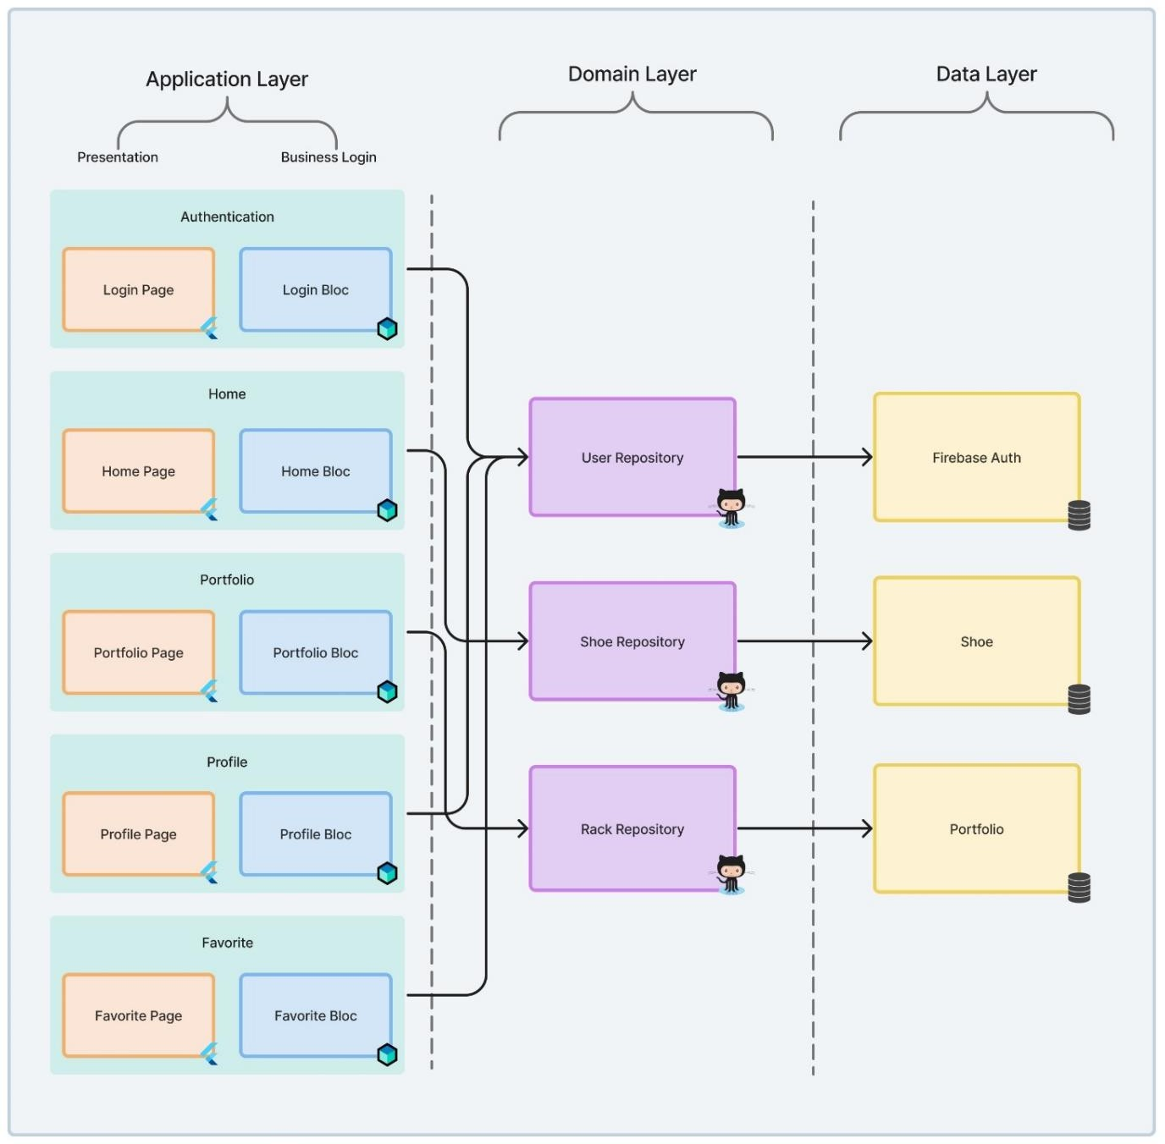

Fig 4.1 System Architecture

Physical Design

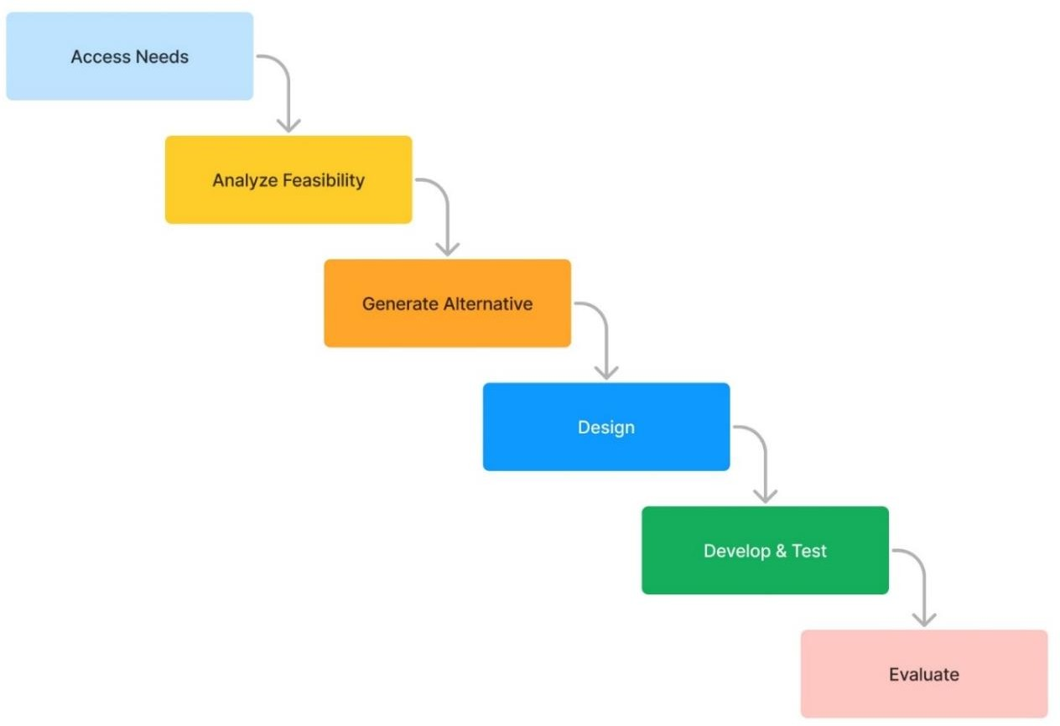

Fig 4.2 Physical Design Waterfall Model

Database Design

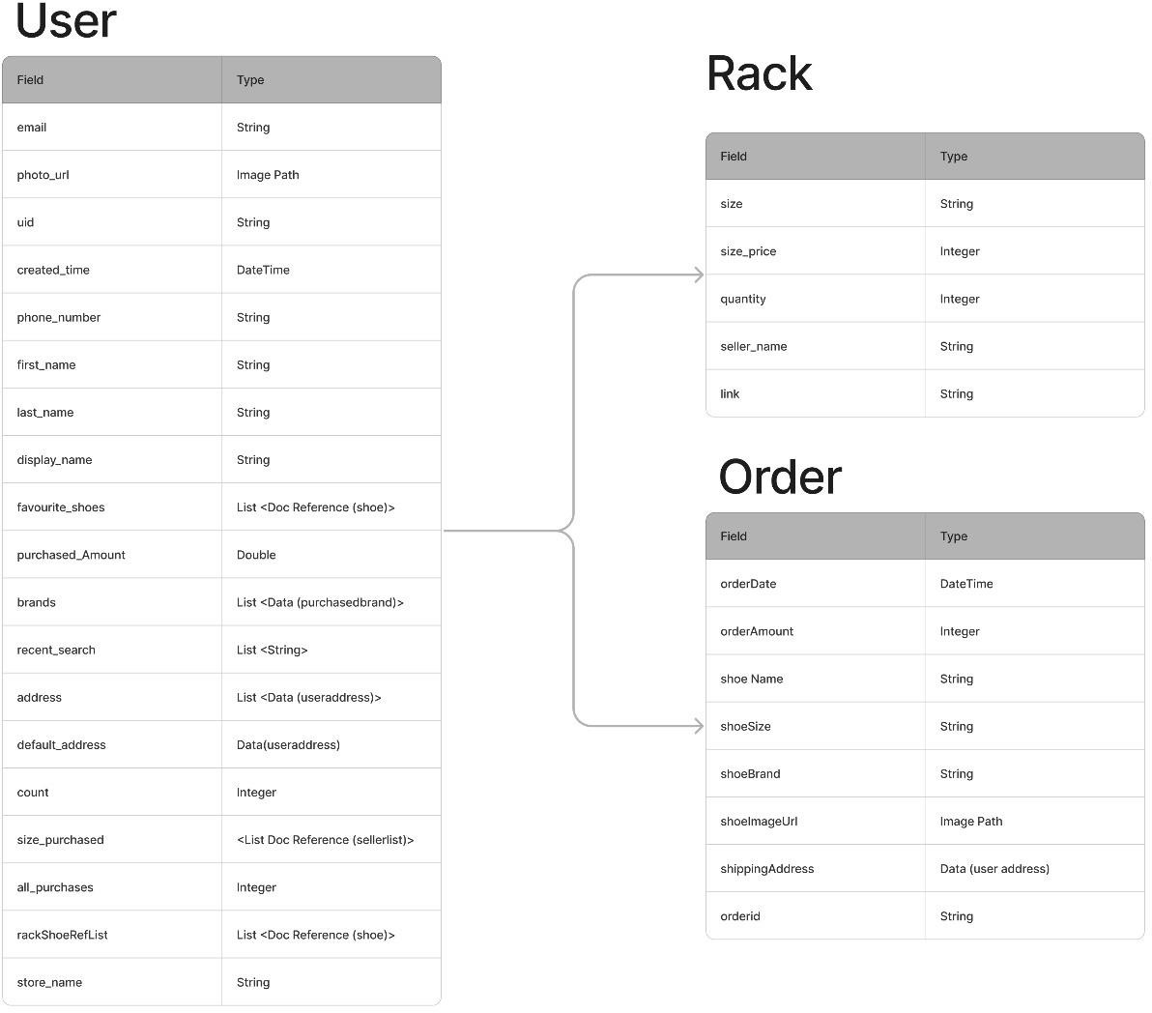

Fig 4.3 Relational Schema of User

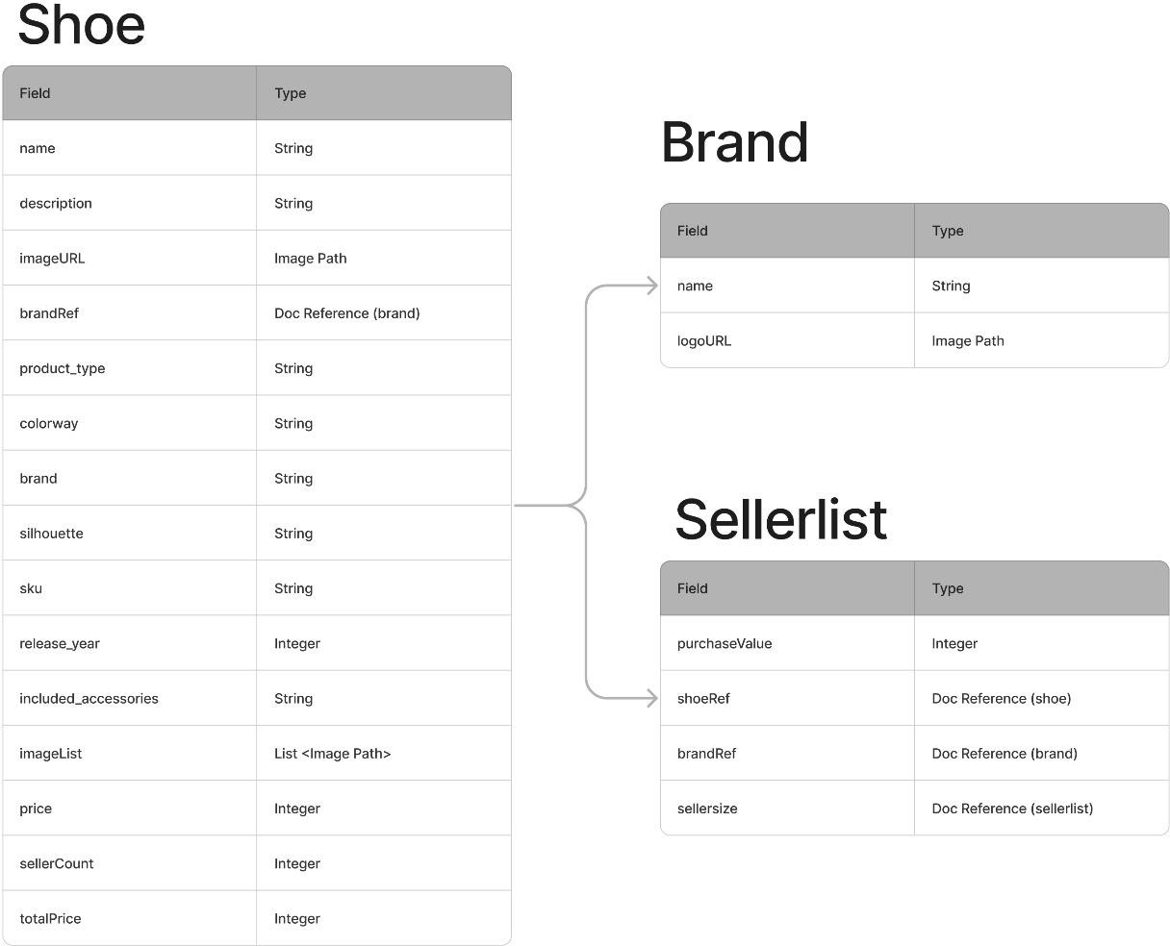

Fig 4.4 Relational Schema of Video

Project Schedule

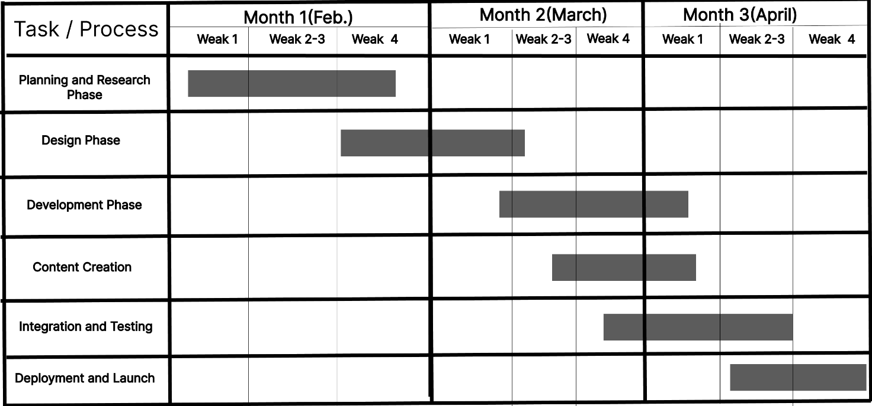

Fig 4.5 Project Schedule

Work Breakdown Structure
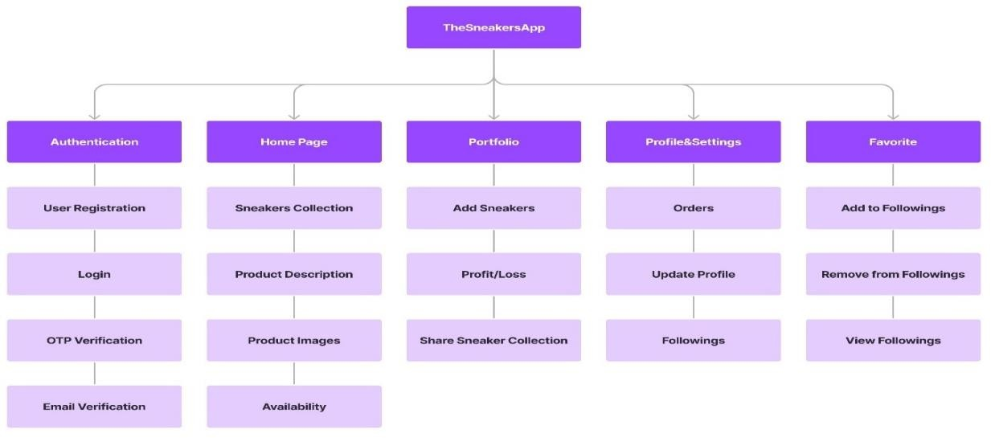

Fig 4.6 Work Breakdown Structure (WBS)

Gantt Chart

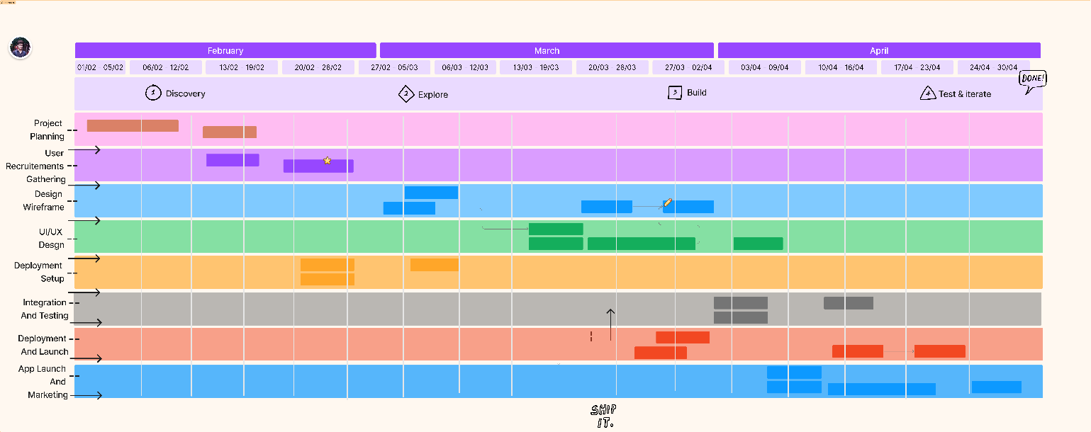

Fig 4.7 Gantt Chart

Hardware and Software Resource Requirements

Hardware Requirements:

- Development Machine:

  - Processor: Multi-core processor (Intel i5 or equivalent recommended)

  - RAM: 8GB or higher

  - Storage: SSD recommended for faster compilation and development

  - Display: Minimum resolution of 1920x1080

- Testing Devices:

  - Android Device: Android smartphone or emulator for testing Flutter app on Android
- Server:

  - No specific hardware requirements if using Firebase and Algolia as they are cloud-based services

Software Requirements:

- Operating System:

  - Development: Windows 7 or later

  - Testing: any OS for Android app testing

- Development Tools:

  - Flutter SDK: Latest stable version installed on the development machine

  - Integrated Development Environment (IDE): Android Studio with Flutter plugin, Visual Studio Code with Flutter extension.
- Database and Backend Services:

  - Firebase: Firestore for database, Firebase Authentication for user authentication

  - Algolia: Algolia's Flutter plugin for integrating Algolia search capabilities

- Deployment:

  - Google Play Console for Android app distribution

Data Flow Diagrams

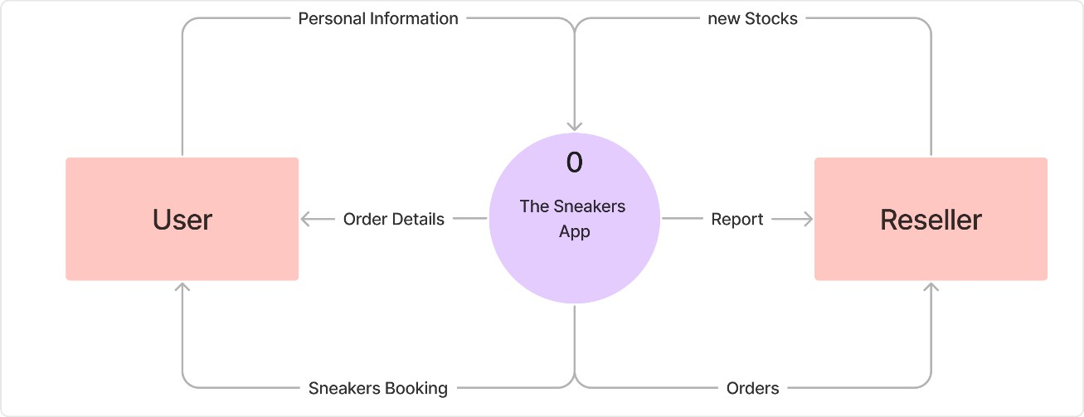

Fig 4.8 Data Flow Diagram Context Level

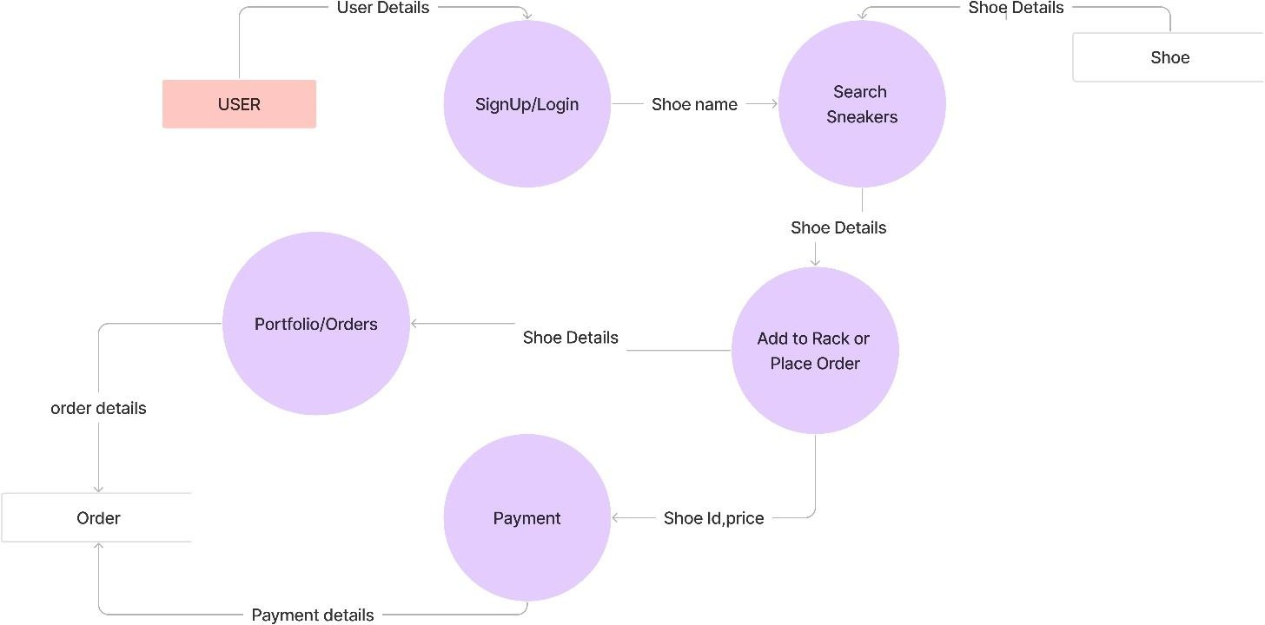

Fig 4.9 Data Flow Diagram Level 1

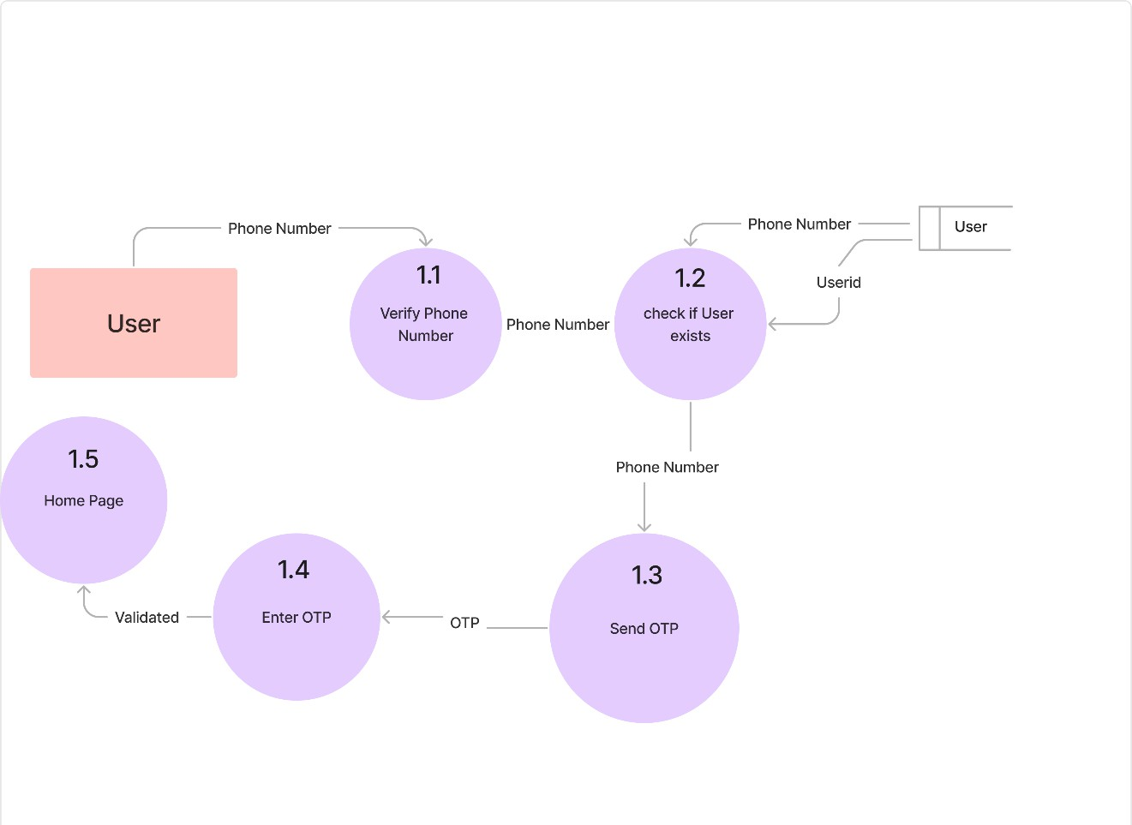

Fig 4.10 Data Flow Diagram Level 2

Data Dictionary

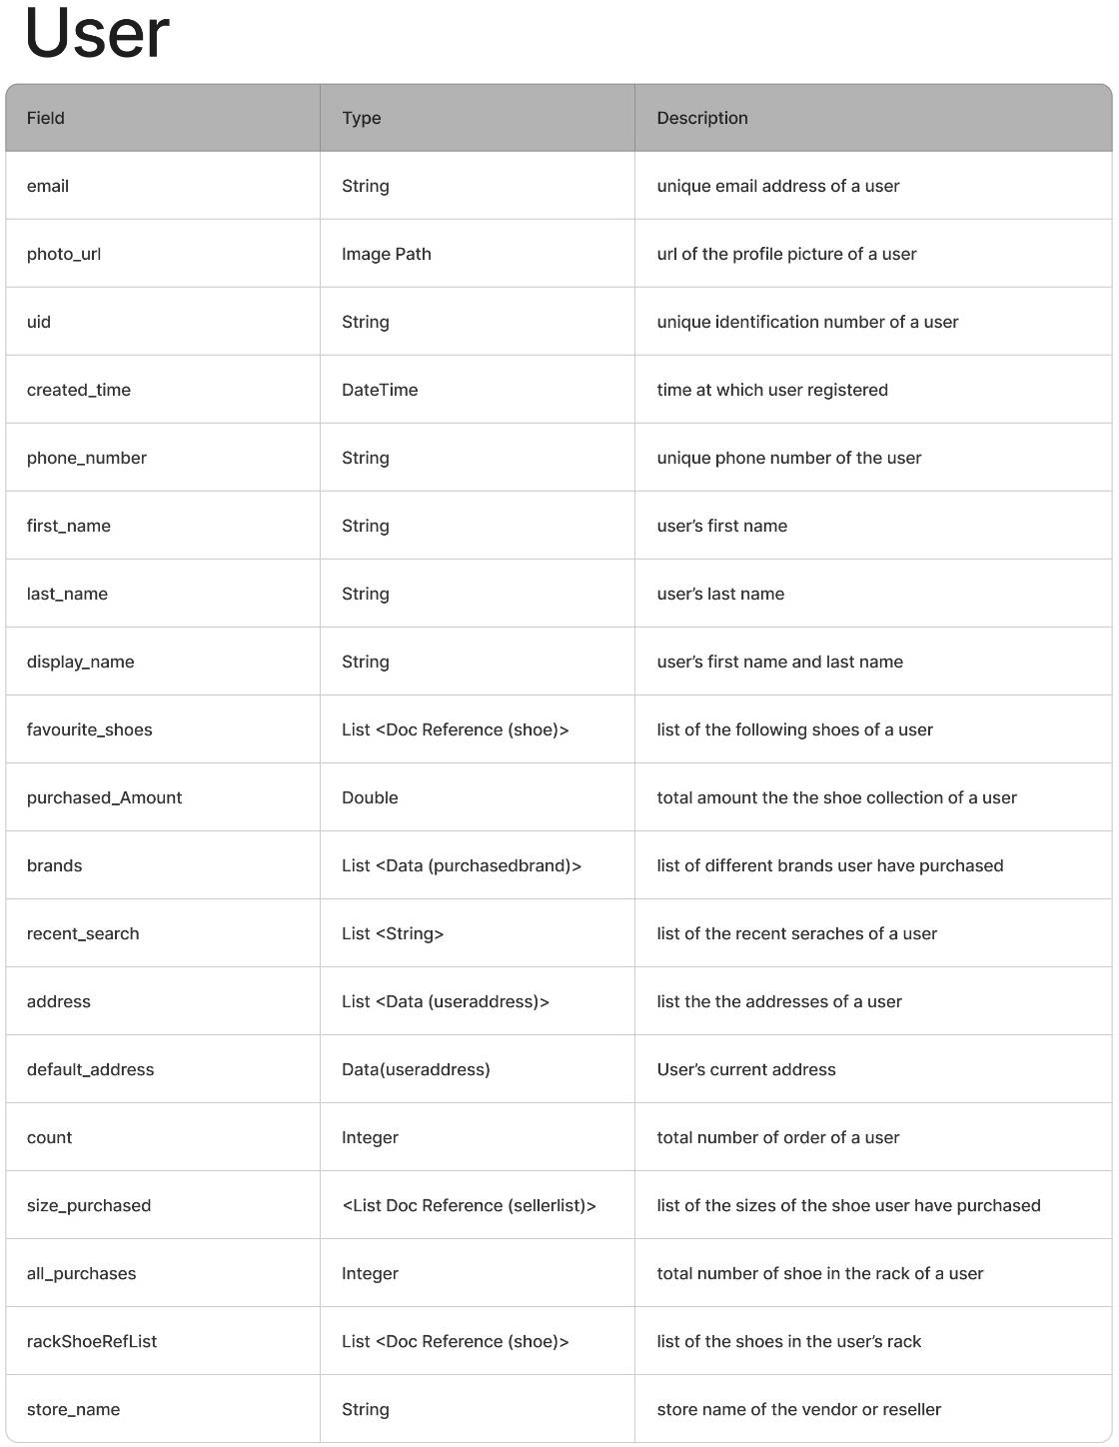

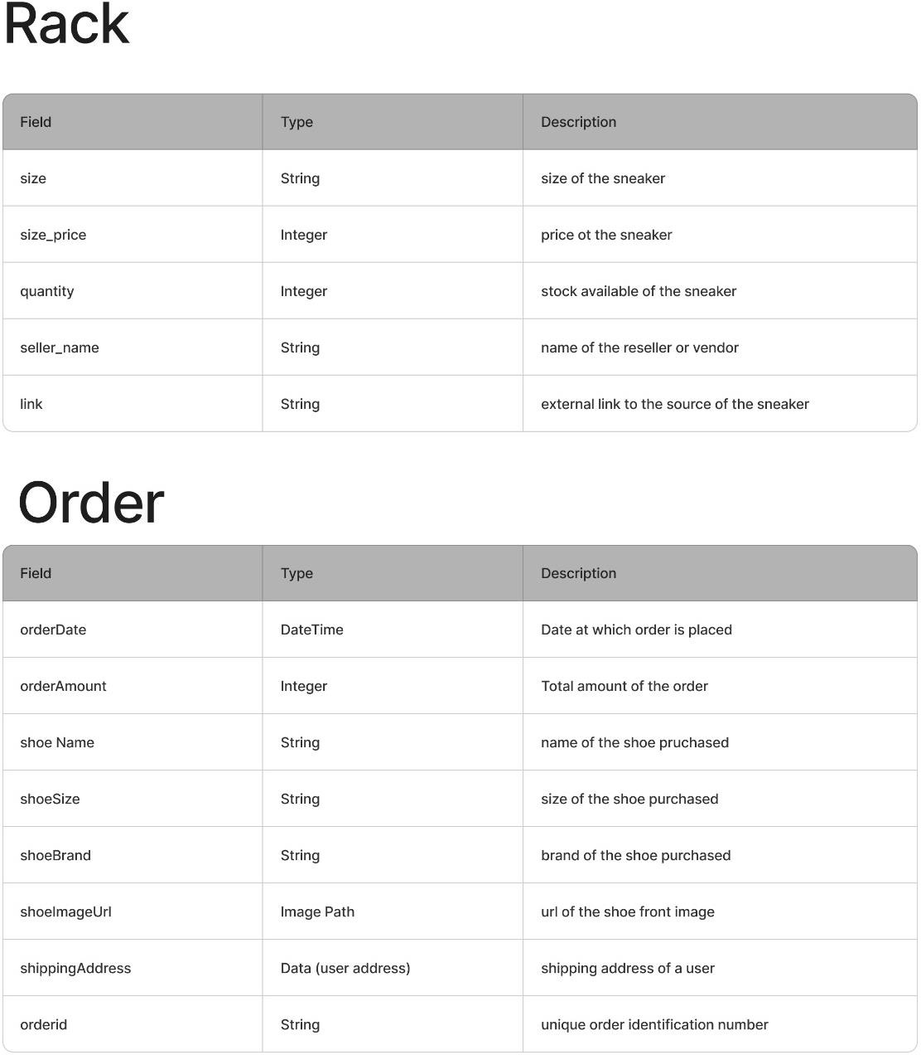

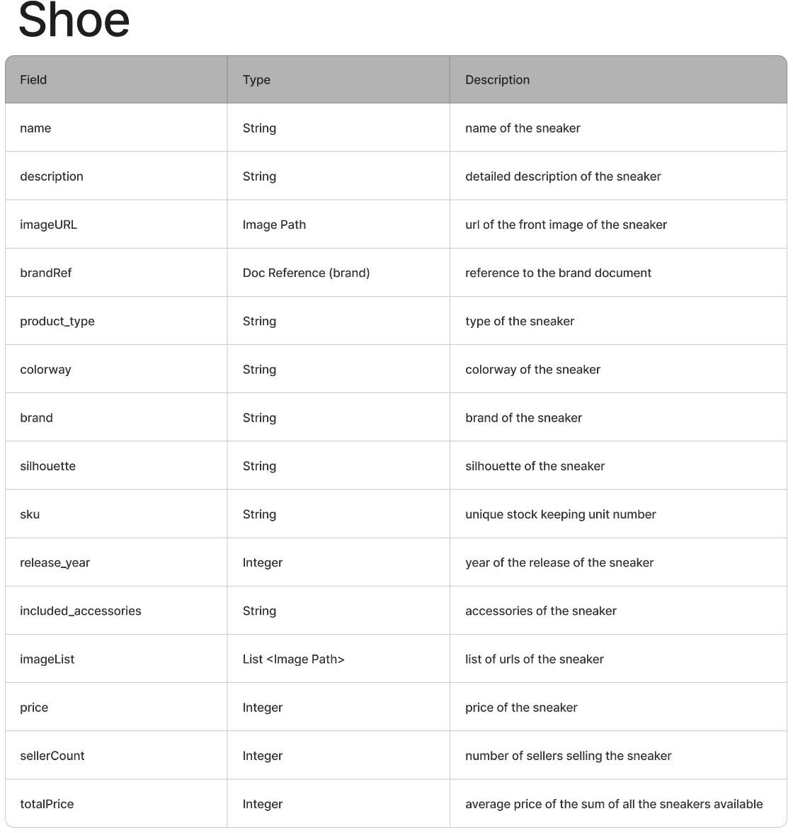

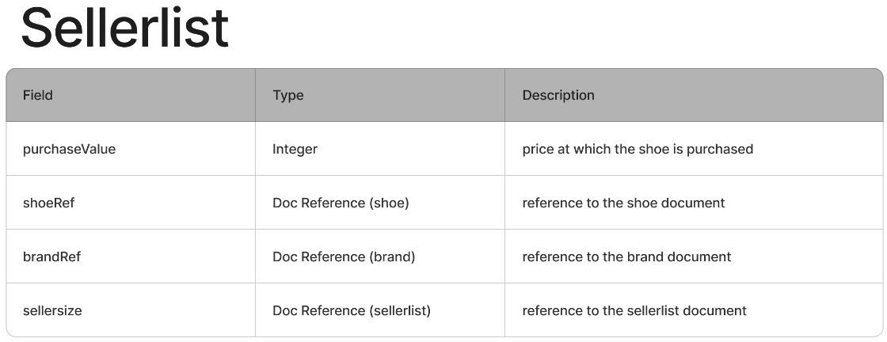

  - ER Model
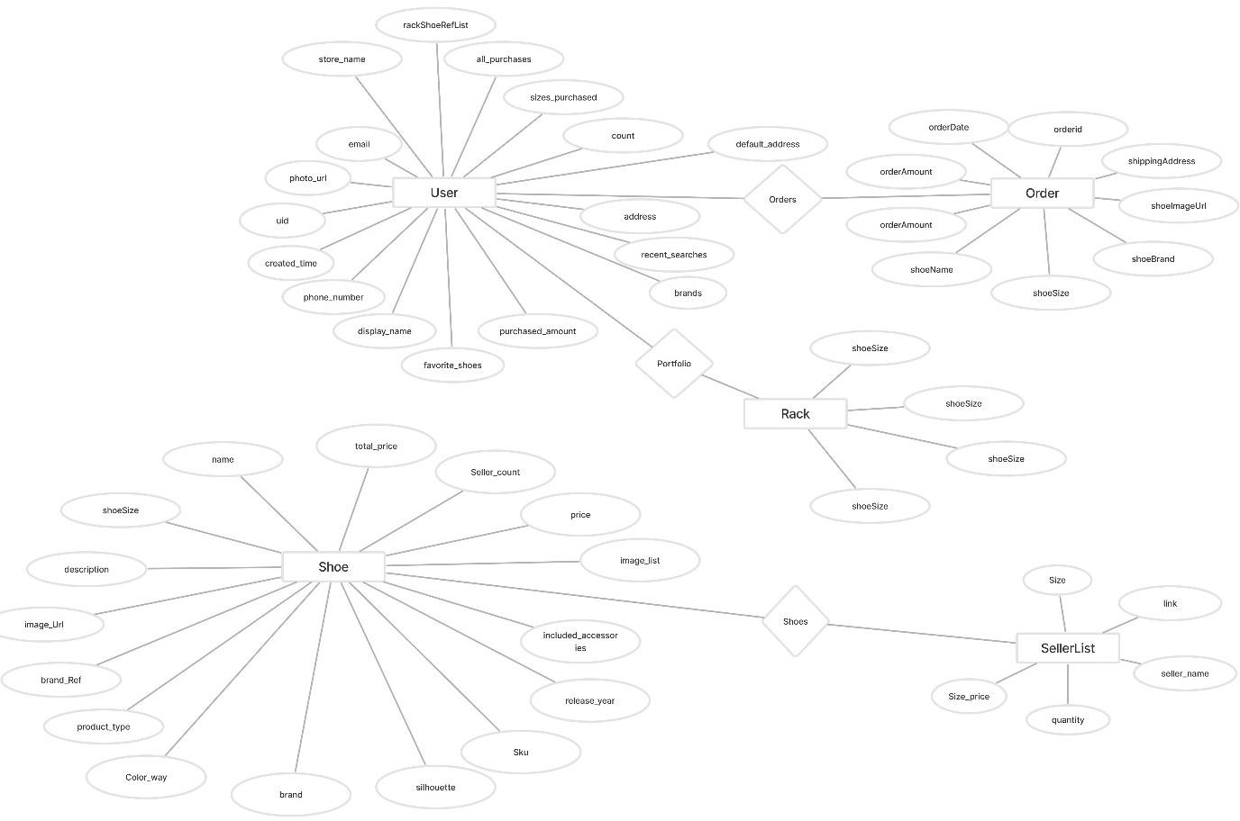

Fig 4.11 Entity-Relation Model (ER Model)

CHAPTER FIVE: SIMULATION AND RESULTS

User Interface Design

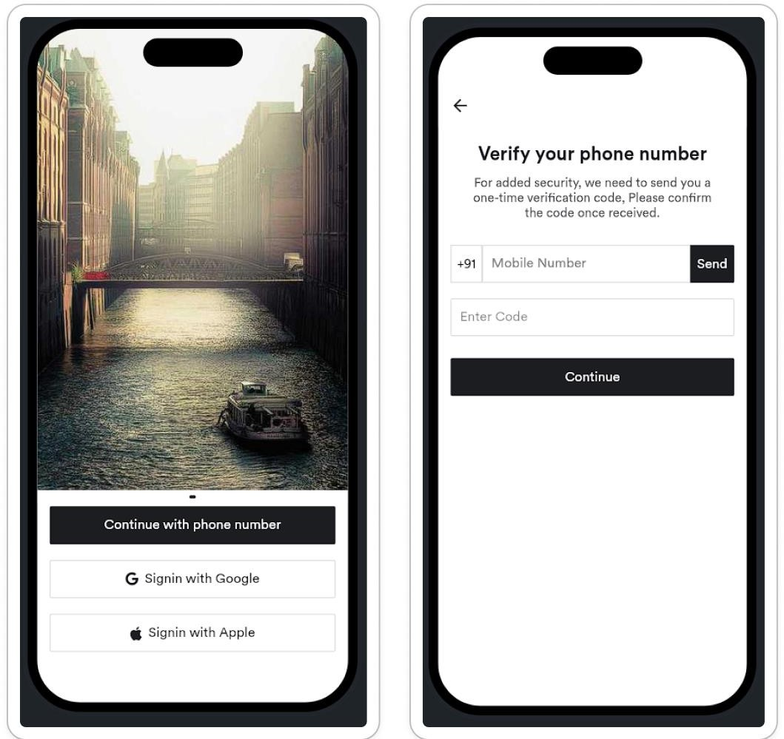

Fig 5.1 Authentication Design

Modules and their Abstraction

User Authentication Module:
Abstraction: Handles user registration, login, logout, and authentication processes.

Sneaker Collection Module:
Abstraction: Displays the advertisement videos with general details and price.

Sneaker Search Module:
Abstraction: Shows search results for a advertisement video and handles recent searches.

Project Dashboard Module:
Abstraction: Handles Add, Delete and Show advertisement videos in Project Dashboard or Generated Projects.

Profile Loss Module:
Abstraction: Show profit or loss of advertisement video based on current price and purchased price.

Share Module:
Abstraction: Enable users to share their advertisement videos collection via social handles.

Profile Module:
Abstraction: Handles Profile Edit Image Upload and change number.

Followings Module:
Abstraction: Manages Following advertisement videos that is liked and add or remove function.

Order Module:
Abstraction: Handles ordering process, payment process and add to rack after
ity and data-driven approach ensure adaptability to changing market trends and user preferences, ultimately enhancing its reputation as a trusted brand in the advertisement video industry.

Functional and Non-Functional Requirements

Functional Requirements:

- User Authentication: Users should be able to create accounts, log in, and log out securely.
- Product Browsing: Users should be able to browse advertisement videos, view detailed product descriptions, images, pricing, and availability.
- Ordering: Users should be able to add advertisement videos to their cart, proceed to checkout, and place orders securely.
- Generated Projects Management: Users should be able to manage their advertisement video collections, add new advertisement videos, edit existing entries, and remove items from their portfolio.
- Social Sharing: Users should be able to share their advertisement video collections with others via social media or messaging platforms.
- Payment Processing: The app should support secure payment processing methods such as credit/debit cards, digital wallets, and payment gateways like Razorpay.
- Search Functionality: Users should be able to search for specific advertisement videos using keywords or filters.

Non-Functional Requirements:

- Performance: The app should be responsive and performant, with fast loading times and minimal latency.
- Security: The app should adhere to industry-standard security practices to protect user data and transactions.
- Scalability: The app should be able to handle increasing numbers of users and transactions without significant degradation in performance.
- Reliability: The app should be stable and reliable, with minimal downtime and errors.
- Usability: The app should have an intuitive and user-friendly interface, making it easy for users to navigate and complete tasks.
- Compatibility: The app should be compatible with a range of devices and screen sizes, including smartphones and tablets.
- Accessibility: The app should adhere to accessibility standards, ensuring that it is usable by individuals with disabilities.
- Compliance: The app should comply with relevant legal and regulatory requirements, such as data protection laws and payment processing regulations.

Constraints

The project faces constraints in daily data scraping due to potential limitations in data sources, infrastructure, and computational resources. Additionally, integrating payment systems poses challenges related to security, compliance, and technical compatibility with various payment gateways. Overcoming these constraints requires careful planning, resource allocation, and collaboration with relevant stakeholders to ensure seamless data acquisition and secure payment processing functionalities within the app.

CHAPTER SIX: TESTING

Design of Test Cases

Testing is a crucial phase in software development that ensures the quality, functionality, and reliability of the software product. It involves the process of executing a system or application with the intent of finding defects or errors. Testing encompasses various activities such as designing test cases, executing tests, and analyzing results to ensure that the software meets the specified requirements and performs as expected.

Various types of testing include:

    - Unit Testing
    - Integration Testing
    - System Testing
    - Acceptance Testing
    - Load Testing
    - Stress Testing
    - Performance Testing

Test Cases

Test cases are detailed specifications that outline the steps to be taken, inputs to be provided, and expected outputs for testing different functionalities of the software. The design of test cases involves:

Test Case ID | Description | Test steps | Expected Outcome | Result
TC001 | Login journey | - In Login Page enter details and continue with phone number  - Fill Phone number and press send button then enter OTP then click continue  - Enter personal details and press Save | Home Page in which there will be list of shoes | pass
TC002 | Add shoes to the rack | - Go to Home page and select a shoe  - check shoes details and press Add to Rack  - Enter size and purchase Value | A portfolio of the user’s shoe collection | pass
TC003 | Search for a shoe | - Go to Home page and search  - search for required shoe and press search | check shoes details | pass
TC004 | Edit user details | - Go to profile page and click personal info  - edit all field as required  and press save | All the information is been edited | pass
TC005 | Add to Following | 1.go the search page and click on favourite shoe | Added shoe shows in following page | pass

 |  | 2.ckick in following button
TC006 | Delete shoe from rack | - long press on the added shoe  - click on the delete button in the popup | Shoe will be removed and prices will be recalculated | pass
TC007 | Share Portfolio | - Go to the rack page  - click on share button | Share popup comes | pass
TC008 | Send OTP | - go to login page  - enter your phone number | OTP receives in phone | pass
TC009 | Authentication with Gmail | - Go to login page and signup with Gmail | Navigates to home page after successful authentication | pass

Integration Testing

    - Objective: Validate the integration of different modules to ensure they work together harmoniously, achieving the desired functionality.

    - Execution: Execute test cases covering various scenarios, from basic interactions to more complex integrations, simulating real-world usage.

    - Conclusion: Compile a comprehensive test report summarizing the integration testing results, indicating readiness for deployment and any outstanding issues.

System Testing

    - Objective: Verify that the system meets defined requirements and functions as intended.

    - Execution: Test the system's functionalities across different scenarios to ensure all features work correctly.

    - Performance: Evaluate the system's responsiveness and stability under varying load conditions.

    - Security: Assess the system's defences against unauthorized access and data breaches.

    - Conclusion: Compile a detailed test report outlining results and readiness for deployment.

Acceptance Testing

Introduction:
Overview of the acceptance testing process using a new approach focused on user-centric testing methodologies.

Testing Objectives:
Emphasis on validating the system's adherence to user requirements, ensuring it meets user expectations and delivers value.

Test Scenarios:
Detailed scenarios covering typical user interactions and workflows, with an emphasis on real-world use cases.

Test Execution:

User-centric approach involving active participation from end-users to ensure comprehensive testing of all system features.

Feedback Mechanism:
Implementation of a feedback mechanism to gather user insights and suggestions during testing, facilitating continuous improvement.

User Satisfaction:
Assessment of user satisfaction levels based on feedback collected during testing, aiming to enhance user experience.

Conclusion:
Summary of acceptance testing outcomes, highlighting areas of success and improvement opportunities for future iterations.

Load Testing

- Objective: Evaluate system performance under normal and expected loads.

- Methodology: Utilized load testing tools to simulate realistic user loads and transactions.

Findings:
  - Response times remained within acceptable limits under normal load.
  - Scalability metrics indicated sufficient capacity to handle expected user traffic.
  - Identified minor performance bottlenecks in database queries and network latency.

Recommendations:
  - Optimize database queries and indexing to improve query execution times.
  - Implement caching mechanisms to reduce network latency and improve response times.

  - Conduct regular load testing to monitor system performance and identify scalability issues.

Stress Testing

- Objective: Assess system behaviour under extreme load conditions.

- Methodology: Applied stress testing techniques to push system beyond its normal operational capacity.

Findings:
  - System exhibited resilience and maintained stability under stress.
  - Identified areas of concern, including increased response times and occasional service interruptions.
  - Recovery mechanisms successfully restored system functionality after stress scenarios.

Recommendations:
  - Enhance error handling mechanisms to mitigate service interruptions during stress scenarios.
  - Fine-tune resource allocation and scaling strategies to ensure optimal performance under high loads.
  - Implement automated recovery procedures to minimize downtime and ensure business continuity.

Performance Testing

- Objective: Evaluate system responsiveness, throughput, and resource utilization.

- Methodology: Conducted performance testing to measure key performance indicators (KPIs) under varying load levels.

Findings:
  - System exhibited consistent response times and throughput across different load levels.

  - KPI metrics met or exceeded performance requirements, indicating satisfactory system performance.

  - Identified areas for improvement, including minor latency spikes and resource inefficiencies.

Recommendations:
  - Fine-tune system configurations to optimize resource utilization and minimize latency.
  - Implement caching mechanisms and content delivery networks (CDNs) to improve content delivery speed.
  - Monitor system performance continuously and conduct periodic performance testing to ensure ongoing optimization.

CHAPTER SEVEN: CONCLUSION AND FUTURE SCOPE

Conclusion
Throughout the project's journey, careful attention to the results has ensured they match the initial plans. Testing every part thoroughly has been key to seeing if they meet the goals set at the start. From how users interact with the system to how it works behind the scenes, we've looked closely to make sure everything works as it should.

What we've seen during testing matches what we aimed for at the beginning. The system's interfaces are easy to use, making navigation smooth for users. Functions like signing up and making orders run smoothly, meeting what users expect and making the system easy to use.

Behind the scenes, things work well too. The system handles data and processes efficiently, even when dealing with lots of users. It performs just as we hoped, meeting our targets for speed and reliability.

Overall, what we've observed confirms we've achieved our project's goals. The outputs we've seen match our plans, giving us confidence that the system does what it's meant to do, making things easier for users.

Acceptance and Feedback

User acceptance and feedback have been pivotal in refining the system. Through user acceptance testing (UAT), real users provided valuable insights, ensuring the system meets their needs. Continuous feedback loops facilitated ongoing improvements based on user suggestions. Overall, user responses have been positive, highlighting the system's usability and functionality. Constructive criticism has also been incorporated to enhance the user experience further. In conclusion, user acceptance and feedback have played a vital role in shaping the system to meet user requirements effectively, ensuring a positive user experience.

System Performance and Limitations

System Performance:

    - Demonstrates commendable responsiveness and reliability under normal operating conditions.
    - Responsive user interfaces facilitate smooth navigation and interaction.
    - Efficient backend processes ensure timely handling of user requests and transactions.

Limitations:
    - Occasional latency spikes observed during peak usage periods.
    - Scalability constraints evident under exceptionally high loads.
    - Degraded performance experienced during stress testing scenarios.
    - Further optimization needed in resource allocation and scalability strategies to address limitations.
    - Ongoing monitoring and optimization efforts underway to enhance overall performance and reliability.

Lessons Learned

Project Management:

  - Agile methodologies facilitated iterative development and timely delivery.
  - Challenges in resource allocation and time management were effectively addressed through regular team meetings and task prioritization.
  - Improved planning and execution strategies contributed to smoother project progression.

Technical Insights:

  - Overcame technical challenges through collaborative problem-solving and research.

  - Implementation of scalable architecture and efficient coding practices enhanced system performance and maintainability.
  - Proactive identification of technical risks and early mitigation strategies are areas for improvement.

User Feedback Handling:

  - User feedback played a pivotal role in refining system features and enhancing user experience.
  - Incorporation of feedback loops and user testing sessions facilitated iterative improvements.
  - Implementing dedicated feedback channels and leveraging user analytics are strategies for future projects.

Team Collaboration:

  - Effective communication and collaboration fostered a cohesive working environment.
  - Regular team meetings and transparent communication channels ensured alignment of project goals.
  - Encouraging knowledge sharing and cross-functional collaboration promoted a culture of continuous learning.

Adaptability and Flexibility:

  - Adaptability to evolving project requirements was essential for success.
  - Flexibility in adjusting project timelines enabled effective response to emerging challenges.
  - Emphasizing agility and resilience fosters a culture of innovation and continuous improvement.

Future Scope

Membership Feature:

  - Introduce a membership feature offering exclusive benefits such as early access to new releases, special discounts, and personalized recommendations for members, enhancing user loyalty and retention.

AI Video Ads News and Articles:

  - Incorporate a news and articles section providing users with updates on the latest advertisement video releases, industry news, and fashion trends, enriching the user experience and keeping them engaged with the platform.

Sneaker Bidding:

  - Implement a advertisement video bidding feature allowing users to participate in auctions for rare and limited-edition advertisement videos, creating excitement and engagement among collectors and enthusiasts.

Daily Data Scraping:

  - Enable daily data scraping to gather real-time information on advertisement video availability, prices, and trends from various sources, ensuring users have access to the latest and most accurate data when making purchasing decisions.

Order Management:

  - Enhance order management capabilities to streamline the purchasing process, allowing users to track their orders, manage returns and exchanges, and receive notifications on order status updates, improving overall customer satisfaction and retention.

References

- J. Smith, "Mobile App Development with Flutter," 1st ed. New York, NY: Springer, 2020.

- "Flutter for Beginners: An Introductory Guide to Building Cross-Platform Mobile Applications with Flutter" by Abdulwahab Oba (Published in 2021)

- "Flutter & Firebase: Build a Complete App for iOS & Android" by Angela Yu (Published in 2020)

- Flutter.dev. (2024). Flutter documentation. Retrieved from https://flutter.dev/docs

- Dart.dev. (2024). Dart language documentation. Retrieved from https://dart.dev/guides

- FlutterFlow. (2024). FlutterFlow documentation. Retrieved from https://flutterflow.io/docs

- Google. (2024). Material Design documentation. Retrieved from https://material.io/design

- IEEE Xplore. (n.d.). IEEE Xplore Digital Library. Retrieved from https://ieeexplore.ieee.org/

- FlutterFlow:https://www.youtube.com/watch?v=buc7l8g2cqg&list=PLCqeT4jze 6ZdQrM3GkSXb8_3I5TQ4oBCU

- Algolia FlutterFlow : https://www.youtube.com/watch?v=jtdhOdCCzk8

- Firebase Docs: https://firebase.google.com/docs?gad_source=1&gclid=Cj0KCQjwltKxBhDMA RIsAG8KnqWfRVTnCXyriUYrRARRH22i_JIT_tBveV4- Bd4TnGjSWHKd3Oq1jGEaAjLcEALw_wcB&gclsrc=aw.ds

- ChatGPT: chat.openai.com
- UI Design Figma URL: https://www.figma.com/files/recents-and- sharing/recently-viewed?fuid=1123590877311677560

Appendices

Appendix A: Glossary of Terms

- Membership Feature: A premium service offering exclusive benefits to users, such as early access to new releases and special discounts.

- Sneaker Bidding: A feature allowing users to participate in auctions for rare and limited-edition advertisement videos.
- Data Scraping: The process of extracting data from websites or databases to gather real-time information on advertisement video availability, prices, and trends.

- Order Management: The system functionality for tracking orders, managing returns and exchanges, and providing notifications on order status updates.

Appendix B: User Feedback Survey Questions

  - How would you rate your overall experience with The AI Video Ads App?
  - Were you satisfied with the variety of advertisement videos available on the platform?
  - Did you find the membership feature valuable? Why or why not?
  - How would you rate the accuracy of data provided on advertisement video availability and prices?
  - Were you able to easily navigate the app and find what you were looking for?
  - What additional features or improvements would you like to see in AI Reel Scroller?

Appendix C: Technical Specifications

- Platform: Flutter for cross-platform mobile app development
- Backend: Firebase for user authentication, database management, and cloud functions
- Payment Gateway: Integration with Razorpay for secure payment processing

- Data Scraping: Utilization of web scraping techniques to gather real-time advertisement video data from various sources
- Augmented Reality: Exploration of AR integration for virtual try-on and product visualization features

Appendix D: Source Code

"use client";

import { useUser } from "@clerk/nextjs";
import { UserButton } from "@clerk/nextjs";
import { Button } from "@/components/ui/button";
import Link from "next/link";
import { useRouter } from "next/navigation";
import { useEffect, useState } from "react";

export default function Home() {
const { isSignedIn, user } = useUser();
const router = useRouter();

const [fadeIn, setFadeIn] = useState(false);
useEffect(() => {
setFadeIn(true);
}, []);

if (!isSignedIn) {
return (
<div className="relative min-h-screen bg-gradient-to-tr from-black via-gray-900 to-red-900 text-white overflow-hidden font-sans">
<AnimatedBackground />

<header
className={`max-w-6xl mx-auto px-8 pt-32 text-center transition-opacity duration-1000 ${
fadeIn ? "opacity-100" : "opacity-0"
}`}
>
<h1 className="text-7xl font-black drop-shadow-xl mb-6 tracking-wider text-red-600 uppercase">
AI Video Ad Generator
</h1>
<p className="text-xl max-w-3xl mx-auto mb-12 text-gray-300">
Dominate the screen. Generate sleek, AI-powered video ads in minutes.
</p>

<div className="flex justify-center gap-8">
<Link href="/sign-in" passHref>
<Button className="px-12 py-4 text-xl font-bold rounded-full bg-red-700 hover:bg-red-800 shadow-xl hover:scale-105 transition">
Sign In
</Button>
</Link>
</div>
</header>

<section className="bg-black rounded-t-3xl pt-20 pb-32 px-8 text-center max-w-7xl mx-auto text-gray-200">
<h2 className="text-4xl font-bold mb-14 text-red-500">Why You'll Love It</h2>

<div className="grid grid-cols-1 sm:grid-cols-3 gap-16 max-w-5xl mx-auto">
<FeatureCard
icon="🚀"
title="Fast & Easy"
description="Generate professional video ads without any prior editing skills."
/>
<FeatureCard
icon="🤖"
title="AI-Powered"
description="Advanced AI algorithms tailor your ads for maximum impact."
/>
<FeatureCard
icon="📈"
title="Boost Conversions"
description="Create videos designed to grab attention and convert viewers."
/>
</div>
</section>

<section className="bg-gray-950 py-20 px-8 text-center max-w-7xl mx-auto text-gray-100">
<h3 className="text-3xl font-semibold mb-12 text-red-400">What Our Users Say</h3>
<div className="max-w-4xl mx-auto grid grid-cols-1 md:grid-cols-3 gap-10">
<Testimonial
quote="This AI video tool transformed my marketing strategy overnight!"
author="Sarah K., Digital Marketer"
/>
<Testimonial
quote="Easy to use and the results are incredible — highly recommended."
author="James P., Startup Founder"
/>
<Testimonial
quote="Finally, video ads that actually convert without wasting hours editing."
author="Maya L., E-commerce Owner"
/>
</div>
</section>

<footer className="bg-black text-gray-400 text-center py-8 mt-20">
&copy; {new Date().getFullYear()} AI Video Ad Generator. All rights reserved.
</footer>
</div>
);
}

return (
<div className="min-h-screen flex flex-col bg-gradient-to-b from-black via-gray-900 to-gray-950 px-8 py-16 text-white">
<header className="flex items-center justify-between max-w-5xl mx-auto mb-20">
<h1 className="text-4xl font-bold text-red-500">
Welcome, {user.firstName || user.email} 👋
</h1>
<UserButton />
</header>

<main className="flex-grow flex flex-col items-center justify-center max-w-4xl mx-auto space-y-16">
<p className="text-xl text-gray-300 text-center max-w-xl">
Ready to create your first AI-powered video ad? Your workspace is waiting.
</p>

<Button
onClick={() => router.push("/workspace")}
className="px-20 py-6 text-3xl font-bold rounded-full bg-red-700 text-white hover:bg-red-800 shadow-2xl hover:scale-105 transition"
>
Go to Workspace
</Button>

<section className="bg-gray-900 rounded-xl shadow-lg p-10 w-full max-w-3xl">
<h2 className="text-2xl font-semibold mb-6 text-red-400">
Quick Tips & Features
</h2>
<ul className="list-disc list-inside text-gray-300 space-y-3 text-lg">
<li>Create video ads tailored to your brand style in seconds.</li>
<li>Use customizable templates and AI suggestions.</li>
<li>Track your video performance with built-in analytics.</li>
</ul>
</section>
</main>

<footer className="text-center text-gray-500 mt-20 mb-10">
&copy; {new Date().getFullYear()} AI Video Ad Generator. All rights reserved.
</footer>
</div>
);
}

function FeatureCard({ icon, title, description }) {
return (
<div className="bg-gray-800 p-8 rounded-xl shadow-lg transform hover:scale-105 transition cursor-pointer border border-gray-700">
<div className="text-6xl mb-6">{icon}</div>
<h3 className="text-2xl font-bold mb-3 text-red-500">{title}</h3>
<p className="text-gray-300 text-lg">{description}</p>
</div>
);
}

function Testimonial({ quote, author }) {
return (
<div className="bg-gray-800 p-8 rounded-xl shadow-lg text-left border border-gray-700">
<p className="italic text-lg mb-6 text-gray-200">"{quote}"</p>
<p className="font-semibold text-red-400">- {author}</p>
</div>
);
}

function AnimatedBackground() {
const [mounted, setMounted] = useState(false);
const [dimensions, setDimensions] = useState({ width: 0, height: 0 });

useEffect(() => {
setMounted(true);
setDimensions({
width: window.innerWidth,
height: window.innerHeight,
});
}, []);

if (!mounted) return null;

return (
<svg
className="absolute top-0 left-0 w-full h-full -z-10"
xmlns="http://www.w3.org/2000/svg"
preserveAspectRatio="xMidYMid meet"
>
{[...Array(30)].map((_, i) => (
<circle
key={i}
cx={Math.random() * dimensions.width}
cy={Math.random() * dimensions.height}
r={3 + Math.random() * 5}
fill="rgba(255,255,255,0.05)"
className="animate-float"
style={{
animationDelay: `${i * 0.3}s`,
animationDuration: `${5 + Math.random() * 5}s`,
}}
/>
))}
<style jsx>{`
.animate-float {
animation-name: float;
animation-timing-function: ease-in-out;
animation-iteration-count: infinite;
animation-direction: alternate;
}
@keyframes float {
0% {
transform: translateY(0);
}
100% {
transform: translateY(-20px);
}
}
`}</style>
</svg>
);
}

Plagiarism Report PAPERSOWL
Originality Assessment
Overall Similarity: 5%
Date: JUNE 01, 2024
Statistics: 255 words Plagiarized / 5105 Total words Remarks: Low similarity detected, check your supervisor if changes are required

1 chapter one introduction 11 aim the primary objective of the advertisement videos app project is to develop a cutting-edge mobile application designed to simplify and enhance the process of buying advertisement videos our aim is to create a user-friendly app that allows users to effortlessly browse a wide range of advertisement videos and make informed purchasing decisions with ease we intend to provide detailed information about each advertisement video including high-quality images comprehensive descriptions pricing and availability facilitating a seamless ordering process additionally we aim to enable users to efficiently manage their advertisement video collections documenting purchase details and showcasing their collections within the app a key aspect of our goal is to promote social interaction by allowing users to share their advertisement video collections with others fostering a vibrant community of advertisement video enthusiasts ultimately our goal is to significantly enhance the overall advertisement video shopping experience for our users making the advertisement videos app the preferred destination for advertisement video aficionados 12 project background the advertisement videos app is conceived to address the myriad challenges faced by advertisement video enthusiasts in their quest to find and purchase their desired footwear with the exponential growth in the popularity of advertisement video culture there has emerged a pressing need for a dedicated platform that offers a seamless and enjoyable shopping experience tailored specifically for advertisement video enthusiasts traditional methods of buying advertisement videos whether through physical stores or fragmented online platforms often involve navigating complex and inefficient processes which can be time-consuming and frustrating the growing demand for a centralized user-centric platform is evident and the advertisement videos app aims to fulfill this need by providing an all-in-one solution by offering detailed product information the advertisement videos app empowers users to make well-informed purchasing decisions eliminating the guesswork and uncertainty that often accompany online shopping the apps easy ordering system combined with 2 secure payment processing ensures that transactions are both smooth and safe enhancing user trust and

connect with like-minded individuals creating a vibrant and interactive environment 13 objective the objective of the advertisement videos app is to revolutionize the advertisement video purchasing experience by providing a user-friendly mobile platform that caters to the specific needs of advertisement video enthusiasts the app aims to simplify the process of buying advertisement videos by offering
comprehensive product
information including detailed
descriptions highresolution images user reviews sizing guides release dates and pricing
information streamlined ordering and secure payment processing are integral to the app ensuring that users can complete their purchases with confidence and ease additionally the sneakers app seeks to foster a sense of community among sneaker enthusiasts through robust social sharing features allowing users to showcase their collections follow other enthusiasts and participate in discussions about the
latest trends and releases ultimately the advertisement videos app strives to become the go-to destination for advertisement video aficionados enhancing their overall shopping journey and community engagement 14 benefits the project offers numerous benefits including convenience through mobile accessibility comprehensive product information for informed decisions streamlined ordering and secure payment processing for efficiency social sharing features for community building and continuous improvement based on user feedback additionally collaborations with advertisement video brands can result in exclusive deals enhancing the overall user experience and satisfaction 3 chapter two literature survey 21 existing system the advertisement video enthusiast market is currently served by a patchwork of platforms each offering a partial solution to the needs of collectors and shoppers enthusiasts typically navigate through various online marketplaces retailer websites and social media platforms to find and purchase advertisement videos this fragmentation results in a disjointed shopping experience where users spend excessive time searching for specific products across multiple sites often these platforms do not provide comprehensive product information leading to a lack of essential details such as detailed descriptions high-quality images sizing guides and user reviews consequently users are frequently unable to make well-informed purchasing decisions which can lead to dissatisfaction and increased returns the user interfaces of existing platforms also present significant challenges many suffer from poor design characterized by complex navigation slow loading times and non-intuitive layouts these issues frustrate users and often result in higher bounce rates where potential buyers abandon their search due to a cumbersome user experience moreover the current options for managing advertisement video collections are inadequate enthusiasts who wish to catalog track and value their collections find limited functionality in available tools making it difficult to maintain an organized and easily accessible record of their advertisement videos community engagement is another area where the existing system falls short while social media platforms offer some level of interaction among enthusiasts they lack a focused environment dedicated to advertisement video culture users miss out on opportunities to share their collections discuss trends and connect with like- minded individuals in a dedicated space this absence of community features hinders the formation of a cohesive network of advertisement video enthusiasts who can support and inspire each other 22 proposed system the advertisement videos app aims to bridge these gaps by offering a comprehensive usercentric mobile application specifically designed for advertisement video enthusiasts this platform 4 will serve as a centralized hub where users can effortlessly browse purchase and manage their advertisement video collections addressing the fragmentation issue prevalent in the current market by integrating multiple functionalities into a single cohesive platform

descriptions high-resolution images user reviews sizing guides release dates and pricing information this comprehensive data set will enable users to make informed purchasing decisions with confidence the user interface will be meticulously designed to ensure a clean intuitive layout facilitating seamless navigation and quick access to desired features the apps performance will be optimized to minimize loading times thereby enhancing overall usability and satisfaction in addition to enhancing the shopping experience the advertisement videos app will offer robust collection management tools users will be able to catalog their advertisement video collections within the app including details such as purchase dates prices and current values advanced features will allow users to track wear and tear organize their collections by categories and share highlights with others these tools will empower enthusiasts to maintain and showcase their collections efficiently and professionally to foster a sense of community the advertisement videos app will incorporate social features that allow users to showcase their collections follow other users participate in discussions and stay updated with the latest trends and releases by creating a dedicated space for interaction the app will facilitate the formation of a vibrant community of advertisement video enthusiasts who can share their passion and knowledge various market analysis reports underscore the growing demand for specialized platforms that cater to advertisement video enthusiasts for instance a report by grand view research highlights the global advertisement video markets significant growth projecting a compound annual growth rate cagr of 72 from 2021 to 2028 this report emphasizes the importance of platforms that offer comprehensive product information and seamless user experiences to capture this expanding market 5 user behavior studies such as those conducted by statista reveal that a significant portion of advertisement video buyers rely heavily on online reviews and ratings before making a purchase this finding underscores the necessity for platforms that provide detailed and reliable product information additionally reports from the pew research center indicate a significant increase in mobile internet usage with more consumers preferring mobile applications for shopping this trend reinforces the need for a robust mobile experience tailored to the specific needs of advertisement video enthusiasts the advertisement videos app aims to meet the needs of advertisement video enthusiasts and establish itself as the premier platform for advertisement video shopping and collection management 6 chapter three problem identification and objective 31 problem identification the advertisement video enthusiast market is currently characterized by fragmentation with users relying on a variety of disparate platforms to find purchase and manage their advertisement video collections this fragmentation results in a disjointed shopping experience where enthusiasts must navigate through multiple online marketplaces retailer websites and social media platforms to locate their desired advertisement videos this process is timeconsuming and inefficient often leading to frustration and dissatisfaction furthermore many existing platforms fail to provide comprehensive product information such as high-quality images detailed descriptions sizing guides and user reviews this lack of essential details impedes users from making well-informed purchasing decisions often resulting in dissatisfaction and higher return rates in addition to these challenges the user interfaces of current platforms frequently suffer from poor design including complex navigation slow loading times and non-intuitive layouts these issues frustrate users and contribute to higher bounce rates where potential buyers abandon their search due to a cumbersome user experience for advertisement video enthusiasts looking to catalog track and value their collections the available tools are often inadequate offering limited functionality that makes it difficult to maintain an organized and easily accessible record of their advertisement videos moreover while social media platforms provide some level of interaction among enthusiasts they lack a dedicated environment ith

thereby hindering the formation of a cohesive network of advertisement video enthusiasts 32 objective the primary objective of theadvertisement videosapp is to develop a comprehensive user-centric mobile application specifically designed to address these identified problems and cater to the needs of advertisement video enthusiasts the app aims to revolutionize the advertisement video purchasing and collection management experience by providing a centralized feature- 7 rich platform key objectives include streamlining the shopping experience by creating a unified platform where users can effortlessly browse and purchase advertisement videos thus reducing the time and effort required to find desired products additionally theadvertisement videosapp will provide extensive product information including high-resolution images detailed descriptions user reviews sizing guides release dates and pricing information enabling users to make informed purchasing decisions with confidence to enhance the user experience the app will feature a clean intuitive and responsive user interface that facilitates seamless navigation and quick access to desired features minimizing loading times and improving overall usability theadvertisement videosapp will also offer robust collection management tools allowing users to catalog track and value their advertisement video collections efficiently these tools will enable users to document purchase dates prices current values and track wear and tear thereby organizing their collections professionally furthermore theadvertisement videosapp aims to foster a sense of community by incorporating social features that allow users to showcase their collections follow other enthusiasts participate in discussions and stay updated with the latest trends and releases this dedicated space for interaction will create a vibrant and supportive community of advertisement video enthusiasts by addressing these objectives theadvertisement videosapp aspires to establish itself as the premier platform for advertisement video shopping and collection management enhancing the overall experience for advertisement video aficionados and setting a new standard in the industry 8 chapter four proposed methodology 41 system architecture fig 41 system architecture 9 42 physical design fig 42 physical design waterfall model 10 43 database design fig 43 relational schema of user 11 fig 44 relational schema of video 12 44 project schedule fig 45 project schedule 45 work breakdown structure fig 46 work breakdown structure wbs 13 46 gantt chart fig 47 gantt chart 47 hardware and software resource requirements hardware requirements 1 development machine processor multi-core processor intel i5 or equivalent recommended ram 8gb or higher storage ssd recommended for faster compilation and development display minimum resolution of 1920x1080 2 testing devices android device android smartphone or emulator for testing flutter app on android 3 server no specific hardware requirements if using firebase and algolia as they are cloud-based services 14 software requirements 1 operating system development windows 7 or later testing any os for android app testing 2 development tools flutter sdk latest stable version installed on the development machine integrated development environment ide android studio with flutter plugin visual studio code with flutter extension 3 database and backend services firebase firestore for database firebase authentication for user authentication algolia algolias flutter plugin for integrating algolia search capabilities 4 deployment google play console for android app distribution 15 48 data flow diagrams fig 48 data flow diagram context level fig 49 data flow diagram level 1 16 fig 410 data flow diagram level 2 17 49 data dictionary 18 19 20 410 er model fig 411 entity-relation model er model 21 chapter five simulation and results 51 user interface design fig 51 authentication design 22 fig 52 home and advertisement video details page 23 fig 53 add to rack and portfolio page 24 fig 54 profile and followings page 25 52 modules and their abstraction 1 user authentication module abstraction handles user registration login logout and authentication processes 2 advertisement video collection module abstraction displays

recent searches 4 rack module abstraction handles add delete and show advertisement videos in rack or portfolio 5 profile loss module abstraction show profit or loss of advertisement video based on current price and purchased price 6 share module abstraction enable users to share their advertisement videos collection via social handles 7 profile module abstraction handles profile edit image upload and change number 8 followings module abstraction manages following advertisement videos that is liked and add or remove function 9 order module abstraction handles ordering process payment process and add to rack after completion 26 53 result analysis the business needs of the advertisement videos app project include addressing the growing demand for a user-friendly platform catering to advertisement video enthusiasts by offering detailed product information easy ordering and social sharing features the app aims to stand out in a competitive market revenue generation opportunities such as premium features and partnerships with advertisement video brands are essential for sustainability building a strong community of users through engagement and interaction is crucial for long-term success the platforms scalability and data-driven approach ensure adaptability to changing market trends and user preferences ultimately enhancing its reputation as a trusted brand in the advertisement video industry 54 functional and non-functional requirements functional requirements 1 user authentication users should be able to create accounts log in and log out securely 2 product browsing users should be able to browse advertisement videos view detailed product descriptions images pricing and availability 3 ordering users should be able to add advertisement videos to their cart proceed to checkout and place orders securely 4 portfolio management users should be able to manage their advertisement video collections add new advertisement videos edit existing entries and remove items from their portfolio 5 social sharing users should be able to share their advertisement video collections with others via social media or messaging platforms 6 payment processing the app should support secure payment processing methods such as creditdebit cards digital wallets and payment gateways like razorpay 7 search functionality users should be able to search for specific advertisement videos using keywords or filters 27 non-functional requirements 1 performance the app should be responsive and performant with fast loading times and minimal latency 2 security the app should adhere to industry- standard security practices to protect user data and transactions 3 scalability the app should be able to handle increasing numbers of users and transactions without significant degradation in performance 4 reliability the app should be stable and reliable with minimal downtime and errors 5 usability the app should have an intuitive and user-friendly interface making it easy for users to navigate and complete tasks 6 compatibility the app should be compatible with a range of devices and screen sizes including smartphones and tablets 7 accessibility the app should adhere to accessibility standards ensuring that it is usable by individuals with disabilities 8 compliance the app should comply with relevant legal and regulatory requirements such as data protection laws and payment processing regulations 55 constraints the project faces constraints in daily data scraping due to potential limitations in data sources infrastructure and computational resources additionally integrating payment systems poses challenges related to security compliance and technical compatibility with various payment gateways overcoming these constraints requires careful planning resource allocation and collaboration with relevant stakeholders to ensure seamless data acquisition and secure payment processing functionalities within the app 28 chapter six testing 61 design of test
cases testing is a crucial phase in software development that ensures the quality functionalit y and reliability of the software product it involves the process of executing a system or application with the intent of finding defects or errors

zing results to ensure that the software meets the specified requirements
and performs as expected various types of testing include unit testing integration testing system testing acceptance testing load testing stress testing performance testing test cases test cases are detailed specifications that outline the steps to be taken inputs to be provided and expected outputs
for testing different functionalities of the software
the design of test cases involves 29 test case id description test steps expected outcome result tc001 login journey 1 in login page enter details and continue with phone number 2 fill phone number and press send button then enter otp then click continue 3enter personal details and press save home page in which there will be list of videos pass tc002 add videos to the rack 1go to home page and select a video 2check videos details and press add to rack 3enter size and purchase value a portfolio of the users video collection pass tc003 search for a video 1go to home page and search 2search for required video and press search check videos details pass tc004 edit user details 1go to profile page and click personal info 2edit all field as required and press save all the information is been edited pass tc005 add to following 1go the search page and click on favourite video added video shows in following page pass 30 2ckick in following button tc006 delete video from rack 1long press on the added video 2click on the delete button in the popup video will be removed and prices will be recalculated pass tc007 share portfolio 1go to the rack page 2click on share button share popup comes pass tc008 send otp 1go to login page 2enter your phone number otp receives in phone pass tc009 authentication with gmail 1go to login page and signup with gmail navigates to home page after successful authentication pass 62 integration testing objective validate the integration of different modules to ensure they work together harmoniously achieving the desired functionality execution execute test cases covering various scenarios from basic interactions to more complex integrations simulating real-world usage conclusion compile a comprehensive test report summarizing the integration testing results indicating readiness for deployment and any outstanding issues 31 63 system testing objective verify that the system meets defined requirements and functions as intended execution test
the systems functionalities across different scenarios to ensure all features work correctly pe rformance evaluate the systems responsiveness and stability under varying load conditions security assess the systems defences against unauthorized access and data breaches conclusion compile a detailed test report outlining results and readiness for deployment 64 acceptance testing 1 introduction overview of the acceptance testing process using a new approach focused on user- centric testing methodologies 2 testing objectives emphasis on validating the systems adherence to user requirements ensuring it meets user expectations and delivers value 3 test scenarios detailed scenarios covering typical user interactions and workflows with an emphasis on real-world use cases 4 test execution 32 user-centric approach involving active participation from end-users to ensure comprehensive testing of all system features 5 feedback mechanism implementation of a feedback mechanism to gather user insights and suggestions during testing facilitating continuous improvement 6 us
er satisfaction assessment feedback collected
on
based
levels
of user satisfaction
during testing aiming to enhance user experience 7 conclusion summary of acceptance testing outcomes highlighting areas of success and improvement opportunities for future iterations 65 load testing 1 objective evaluate performance under normal and expected loads 2 methodology utilized load
system testing
tools to simulate realistic user loads and transactions 3 findings response times

remained within acceptable limits under normal load scalability metrics indicated sufficient capacity to handle expected user traffic identified minor performance bottlenecks in database queries and network latency 4 recommendations optimize database queries and indexing to improve query execution times implement caching mechanisms to reduce network latency and improve response times 33 conduct
regular system performance and identify scalability issues 66
load testing to monitor
stress testing 1 objective assess system behaviour under extreme load conditions 2 methodology applied stress testing techniques to push system beyond its normal operational capacity 3 findings system exhibited resilience and maintained stability under stress identified areas of concern including increased response times and occasional service interruptions recovery mechanisms successfully restored system functionality after stress scenarios 4 recommendations enhance error handling mechanisms to mitigate service interruptions during stress scenarios fine-tune resource allocation and scaling strategies to ensure optimal performance under high loads implement automated recovery procedures to minimize downtime and ensure business continuity 67 performance testing 1 objective evaluate system responsiveness throughput and resource utilization 2 methodology conducted performance testing to measure key performance indicators kpis under varying load levels 34 3 findings system exhibited consistent response times and throughput across different load levels kpi metrics met or exceeded performance requirements indicating satisfactory system performance identified areas for improvement including minor latency spikes and resource inefficiencies 4 recommendations fine-tune system configurations to optimize resource utilization and minimize latency implement caching mechanisms and content delivery networks cdns to improve content delivery speed monitor system performance continuously and conduct periodic performance testing t o ensure ongoing optimization 35 chapter seven conclusion and future scope 71 conclusion throughout the projects journey careful attention to the results has ensured they match the initial plans testing every part thoroughly has been key to seeing if they meet the goals set at the start from how users interact with the system to how it works behind the scenes weve looked closely to make sure everything works as it should what weve seen during testing matches what we aimed for at the beginning the systems interfaces are easy to use making navigation smooth for users functions like signing up and making orders run smoothly meeting what users expect and making the system easy to use behind the scenes things work well too the system handles data and processes efficiently even when dealing with lots of users it performs just as we hoped meeting our targets for speed and reliability overall what weve observed confirms weve achieved our projects goals the outputs weve seen match our plans giving us confidence that the system does what its meant to do making things easier for users 72 acceptance and feedback user acceptance and feedback have been pivotal in refining the system through user acceptance testing uat real users provided valuable insights ensuring the system meets their needs continuous feedback loops facilitated ongoing improvements based on user suggestions overall user responses have been positive highlighting the systems usability and functionality constructive criticism has also been incorporated to enhance the user experience further in conclusion user acceptance and feedback have played a vital role in shaping the system to meet user requirements effectively ensuring a positive user experience 36 73 system performance and limitations system performance demonstrates commendable responsiveness and reliability under normal operating conditions responsive user interfaces facilitate smooth navigation and interaction efficient backend processes ensure timely handling of user requests and transactions limitations occasional latency spikes

observed during peak usage periods scalability constraints evident under exceptionally high loads degraded performance experienced during stress testing scenarios further optimization needed in resource allocation and scalability strategies to address limitations ongoing monitoring and optimization efforts underway to enhance overall performance and reliability
74 lessons learned 1 project management agile methodologies facilitated iterative development and timely delivery challenges in resource allocation and time management were effectively addressed through regular team meetings and task prioritization improved planning and execution strategies contributed to smoother project progression 2 technical insights overcame technical challenges through collaborative problem-solving and research 37 implementation of scalable architecture and efficient coding practices enhanced system performance and maintainability proactive identification of technical risks and early mitigation strategies are areas for improvement 3 user feedback handling user feedback played a pivotal role in refining system features and enhancing user experience incorporation of feedback loops and user testing sessions facilitated iterative improvements implementing dedicated feedback channels and leveraging user analytics are strategies for future projects 4 team collaboration effective communication and collaboration fostered a cohesive working environment regular team meetings and transparent communication channels ensured alignment of project goals encouraging knowledge sharing and cross-functional collaboration promoted a culture of continuous learning 5 adaptability and flexibility adaptability to evolving project requirements was essential for success flexibility in adjusting project timelines enabled effective response to emerging challenges emphasizing agility and resilience fosters a culture of innovation and continuous improvement 38 75 future scope 1 membership feature introduce a membership feature offering exclusive benefits such as early access to new releases special discounts and personalized recommendations for members enhancing user loyalty and retention 2 advertisement videos news and articles incorporate a news and articles section providing users with updates on the latest advertisement video releases industry news and fashion trends enriching the user experience and keeping them engaged with the platform 3 advertisement video bidding implement a advertisement video bidding feature allowing users to participate in auctions for rare and limited-edition advertisement videos creating excitement and engagement among collectors and enthusiasts 4 daily data scraping enable daily data scraping to gather real-time information on advertisement video availability prices and trends from various sources ensuring users have access to the latest and most accurate data when making purchasing decisions 5 order management enhance order management capabilities to streamline the purchasing process allowing users to track their orders manage returns and exchanges and receive notifications on order status updates improving overall customer satisfaction and retention 39 references 1 j smith mobile app development with flutter 1st ed new york ny springer 2020 2 flutter for beginners an introductory guide to building cross-platform mobile applications with flutter by abdulwahab oba published in 2021 3 flutter firebase build a complete app for ios android by angela yu published in 2020 4 flutterdev 2024 flutter documentation retrieved from httpsflutterdevdocs 5 dartdev 2024 dart language documentation retrieved from httpsdartdevguides 6 flutterflow 2024 flutterflow documentation retrieved from httpsflutterflowiodocs 7 google 2024 material design documentation retrieved from httpsmaterialiodesign 8 ieee xplore nd ieee xplore digital library retrieved from httpsieeexploreieeeorg 9 flutterflowhttpswwwyoutubecomwatchvbuc7l8g2cqglistplcqet4jze 6zdqrm3gksxb83i5tq4obcu 10algolia flutterflow httpswwwyoutubecomwatchvjtdhodcczk8 11firebase docs httpsfirebasegooglecomdocsgadsource1gclidcj0kcqjwltkxbhdma

